

Faculty of Science and Engineering

School of Computing and Information Science

**Module MOD002589:**

**Database Design and Implementation**

**Element 010**

**Report**

**SID NUMBER: REMOVED**

Trimester 1 – 2023

Submission deadline: REMOVED

Table of Contents

1. Introduction. 4

1.1 Resources used. 4

2. Requirement Analysis. 5

2.1 Description of three e-commerce websites chosen. 5

2.1.1 argos.co.uk 5

2.1.2 currys.co.uk 5

2.1.3 johnlewis.com 5

2.2 List of data fields. 6

2.2.1 List of data fields from Currys.co.uk website. 7

2.2.2 List of data fields from Johnlewis.co.uk website. 13

2.2.3 List of data fields from Argos.co.uk website. 19

2.3 Finalized List. 25

2.3.1 The generic list. 25

2.3.2 New attributes and reasons of adding them. 25

2.3.3 Removed attributes and reasons of deleting them. 26

3. Database Design. 27

3.1 Entity Relationship Modeling. 27

3.1.1 Initial Entity Relationship Model. 27

3.1.2 Extended Entity Relationship Diagram 28

3.2 Normalized Model 30

3.2.1 Normalization 30

3.2.2 Normalized EERD model 31

3.3 Database Schema 32

**Customer** 33

**CustomerProduct** 33

**Purchase** 34

**Special Offers** 34

**Order** 34

**Delivery_Details** 35

**Product** 36

**OrderProduct** 37

**ProductCategory** 37

**Category** 37

**CategorySpecific_Specifications** 37

**Specification_Values** 37

4 Database Implementation 38

4.2 Customer table implementation 39

4.3 Purchase table implementation 40

4.4 Product table implementation 41

4.5 Special_Offers table implementation 42

4.6 CustomerProduct table implementation 43

4.7 Order table implementation 44

4.8 Delivery_Details table implementation 45

4.9 OrderProduct table implementation 46

4.10 Category table implementation 47

4.11 ProductCategory table implementation 48

4.12 CategorySpecific_Specifications table implementation 49

4.13 Specification_Values table implementation 50

5 SQL Queries 51

5.1 Query 1 52

5.1.1 Business purpose 52

5.1.2 Query in natural language 52

5.1.3 SQL code and output 52

5.1.4 Explanation of output table 53

5.2 Query 2 54

5.2.1 Business purpose 54

5.2.2 Query in natural language 54

5.2.3 SQL code and output 54

5.2.4 Explanation of output table 55

5.3 Query 3 56

5.3.1 Business purpose 56

5.3.2 Query in natural language 56

5.3.3 SQL code and output 56

5.3.4 Explanation of output table 57

5.4 Query 4 58

5.4.1 Business purpose 58

5.4.2 Query in natural language 58

5.4.3 SQL code and output 59

5.4.4 Explanation of output tables 62

5.5 Query 5 63

5.5.1 Business purpose 63

5.5.2 Query in natural language 63

5.5.3 SQL code and output 63

5.5.4 Explanation of output table 64

6 References 65

# **Introduction.**

The primary objective of this report is to showcase the comprehension and application of concepts taught in the Database Design and Implementation module. Within this report, we delve into the investigation of specific e-commerce websites, extracting and scrutinizing the attributes they store. Subsequently, we proceed to outline the design of the proposed database. The initial design undergoes meticulous scrutiny and validation through the application of normalization techniques, and this entire process is comprehensively documented in the respective sections. Following the design validation, the database is constructed according to the specified design parameters and populated with test data. Lastly, we generate sample SQL queries to assess the functionality and performance of the database.

## **Resources used.**

Following resources were required to successfully complete the assignment:

1. Laptop running MacOS Ventura 13.5.2
2. “Grammarly” cloud-based typing assistant, version 3.2.2.0
3. Internet browser “Safari”, version 17.0
4. Internet browser “Google chrome”, version 117.0.5938.92
5. “Lucidchart”, version 3.6.1
6. Tablet running IpadOS 17.0.3
7. Language Model “ChatGPT”, version 4

# **Requirement Analysis.**

## **Description of three e-commerce websites chosen.**

All three websites chosen for this task serve as online storefronts for companies operating in the same market segment: the retail sale of computer equipment and consumer electronics. The evaluation of their purchasing functionalities encompassed the process of registering as a new customer, navigating through product categories, selecting a product (in this case, a laptop), and adding it to the shopping basket. This standardized approach allowed for a simplified comparison of the user experience across these websites.

### argos.co.uk

Argos.co.uk is a well-known British catalog retailer and e-commerce platform. Established in 1972, it offers a wide range of products, from electronics to clothing, available for purchase online at Argos.co.uk and in physical stores across the UK and Ireland. Argos is recognized for its convenient shopping options, including click-and-collect services and regular discounts. It is part of the Sainsbury's Group.

### currys.co.uk

Currys.co.uk is a leading British electronics and electrical retailer known for its wide range of consumer products. Established in the UK, it offers a diverse selection of electronics, including home appliances, computing devices, home entertainment systems, cameras, smart home gadgets, and kitchen appliances. With both online and physical stores, Currys.co.uk is a popular choice for tech enthusiasts. It is part of the Dixons Carphone group, a major European retailer.

### johnlewis.com

John Lewis & Partners, often referred to as John Lewis, is a well-known British high-end department store chain. Founded in 1864, it is famous for offering a wide range of products, including clothing, furniture, electronics, home goods, and more. John Lewis is also known for its commitment to quality and customer service. In addition to its brick-and-mortar stores, John Lewis has a strong online presence through its website, JohnLewis.com, where customers can shop for a wide variety of products and enjoy the convenience of online shopping. John Lewis & Partners is part of the John Lewis Partnership, a unique business model in which the employees are also partners in the company, sharing in its profits and decision-making. This cooperative approach is a distinctive feature of the brand.

## **List of data fields.**

Below you will find three tables of attributes. All these attributes were extracted during analyzation of chosen websites. Some of the attributes were taken from the fields that must be filled by customer, others were taken by analyzing the tick boxes. Moreover, there are attributes that store auto-generated data. The remaining attributes were gathered from the information displayed on the website.

I have split the attributes into the sets of common attributes that are related to one group of data. After placing the attributes, I have got four groups: Customer, Product, Order, Purchase. For the sake of readability, I have colored them. Customer – blue, Product – green, Order – red, Purchase – yellow.

### List of data fields from Currys.co.uk website.

|  |  |  |  |  |
| --- | --- | --- | --- | --- |
| First name* | Name* | Type* | Special offers | Order number* |
| Last name* | Price* | Processor* | Product | Order date* |
| Email* | Old Price | Screen size* | Amount of product | Invoice number* |
| Phone number | Stock* | RAM* | Total price | Invoice date* |
| Password* | Color* | Number of cores* | Collection/Delivery* | Shipping Information* |
| Title* | IsBundle* | Storage capacity* | Fast/Standard Delivery | Promocode |
| Company | Manufacturer’s Information* | Operating system* | Delivery time and date | Expiry date |
| Address1* | Technical Specs* | Best for* | Delivery Address as Billing/Billing Address | Card verification code* |
| Address2 | Reviews | Storage type* | Pick up Address | Card holder’s Name |
| City* | Product code* | Ports* | Get SMS | Payment method |
| Country | Manufacturer* | Features* | Get emails | Card number* |

Those attributes that have “*” (asterisk) in the end, are mandatory. Remaining attributes will be able to contain NULL values.

The user, during the registration, is required to enter delivery address and billing address, having option of selecting the same address. I could’ve omitted the “Billing address” attribute, but decided to keep it, because the user can always change the delivery and billing addresses and make them different. All the other Customer attributes are going to be almost the same for all three websites.

During the analysis of the Products, I have noticed that there are many common parameters for each category of computers. Therefore, I have decided to add them to be more specific when querying the database. Other attributes, more uncommon for each category of computers, will be stored in the Technical Specs attribute.

There are also two attributes that may seem to be very similar. “IsBundle” and “Special offers”. “IsBundle” was added because when the customer is on the product page, he/she is offered a bundle or a suggested accessory to the chosen product. “Special offers” attribute contains the list of offers that are added to the product.

In the Order entity, it is worth noting that there are four additional attributes that store auto-generated data: “Order number”, “Order date”, “Invoice number”, “Invoice date”. These are needed to be sent to the customer, after the purchase. I have added the same attributes to the Order entities of the other websites.

The last data field mostly contains the attributes that hold the card’s details. However, there is small chance that companies will store such important information in the database, because it dramatically increases the opportunity to be stolen.

In the following figures you will find the website’s details, where I have mostly taken the information, and how it looks.

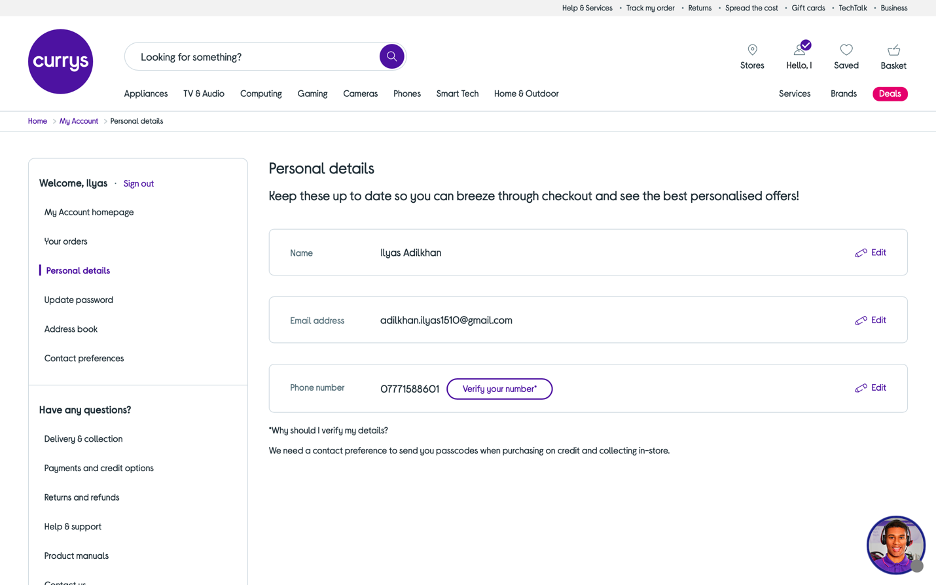

Figure 1 shows the “Personal details” section in “My account” section of Currys.co.uk

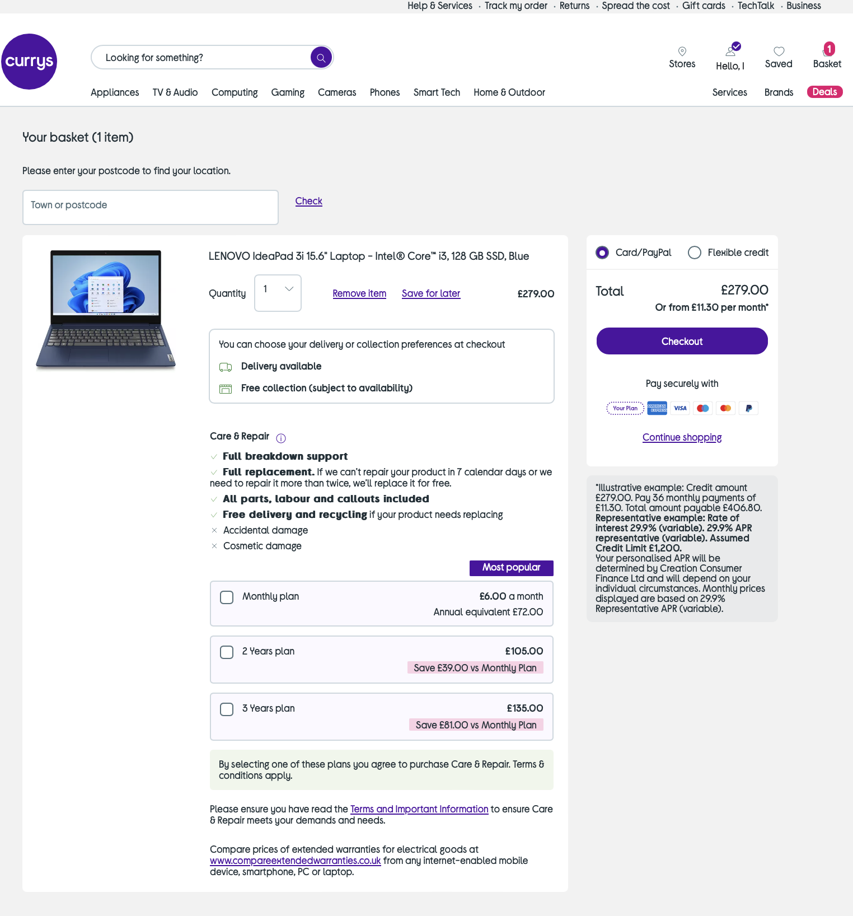

Figure 2 shows the “Basket” section of Currys.co.uk

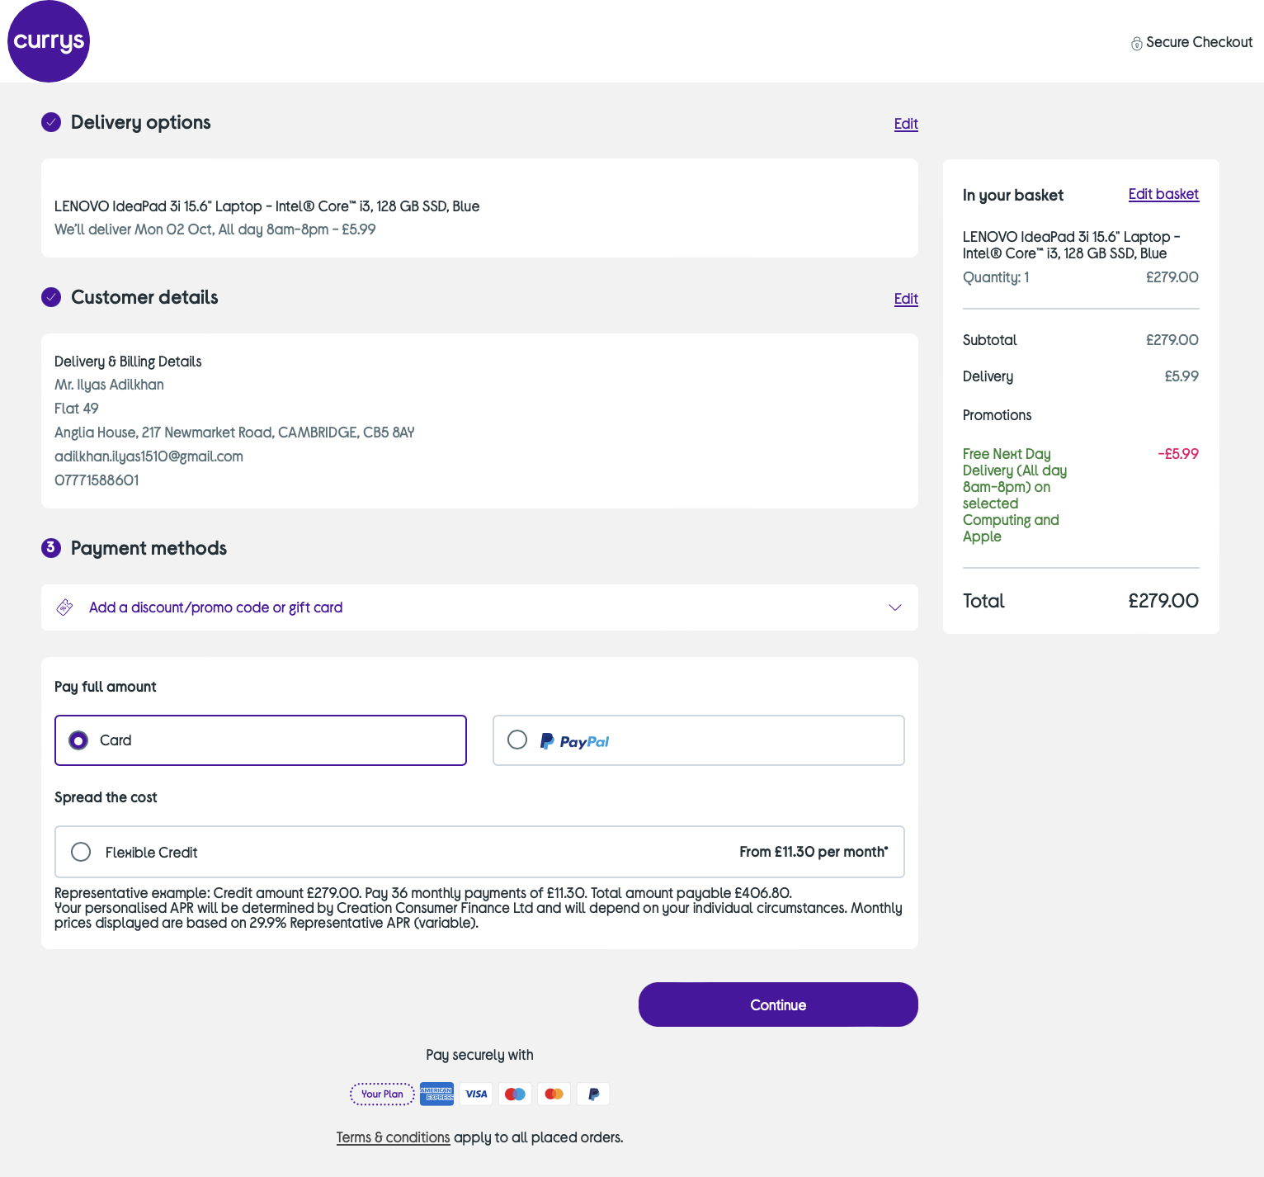

Figure 3 shows the “Checkout” section of Currys.co.uk

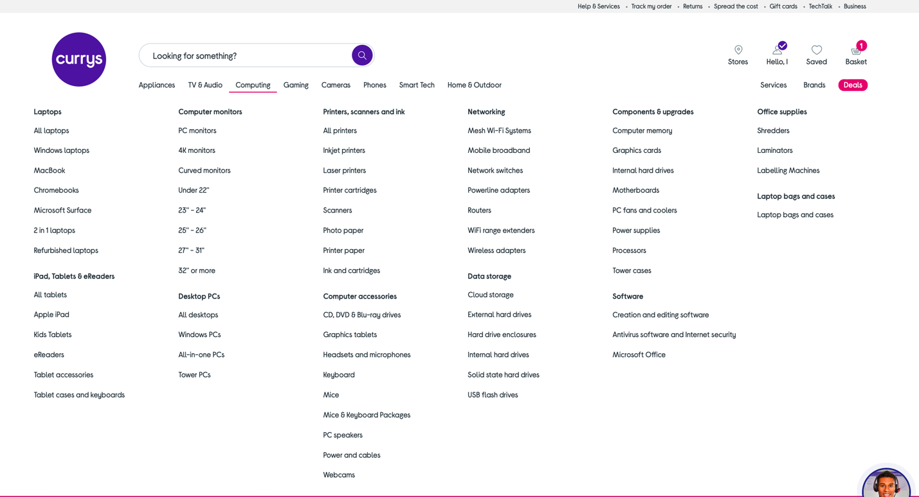

Figure 4 shows the variety of gadgets and computers in “Computing section” of Currys.co.uk

### List of data fields from Johnlewis.co.uk website.

|  |  |  |  |  |
| --- | --- | --- | --- | --- |
| Title | Alternative Phone number | Save for later | Total price | Invoice date* |
| First name* | Name* | Brand* | Standard delivery | Shipping information* |
| Last name* | Price* | Screen size* | Click & collect | Collection point |
| Phone number* | Old Price | Processor* | Protection | Payment method |
| Address line 1* | Special offer | Operating system* | Pick up | Card number |
| Address line 2 | Protect Plus | Discount | Delivery | Name on card |
| Address line 3 | Technical specs* | RAM* | Delivery options | Expiry date |
| City* | Manufacturer* | Storage Capacity* | Gift card | CVC |
| Password* | Stock* | Computing features | Order number* | Don’t send emails |
| Email* | Color* | Product | Order date* |
| DOB | Rating review | Amount | Invoice number* |

Those attributes that have “*” (asterisk) in the end, are mandatory. Remaining attributes will be able to contain NULL values.

During the analysis I have found that Customer will be required to provide more information, such as: date of birth, alternative phone number or third additional address. Therefore, these attributes were added to the Customer entity.

Product attributes are almost the same compared to the previous website’s Product attributes. However, the website provides additional warranty for the accidental breaks of the product, hence “Protect Plus” was added to the Product entity.

When I was analyzing the “Checkout” section, I have noticed that the delivery price was a separate attribute. However, for the sake of simplicity, I have decided to exclude delivery price from all the lists of data fields for each website, because it can be held in the application code, and only the total price will be in the database.

“Don’t send emails” is the attribute in “Purchase” entity that is responsible for the user’s choice, whether user want to get emails or not.

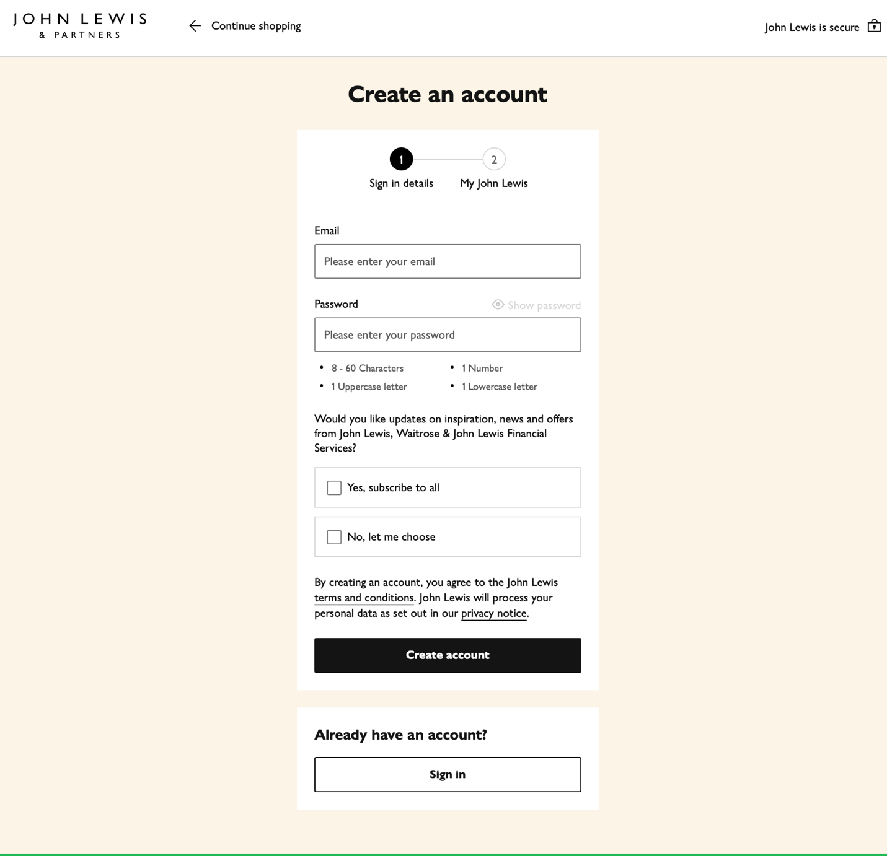

Figure 5 shows the registration form from Johnlewis.co.uk website.

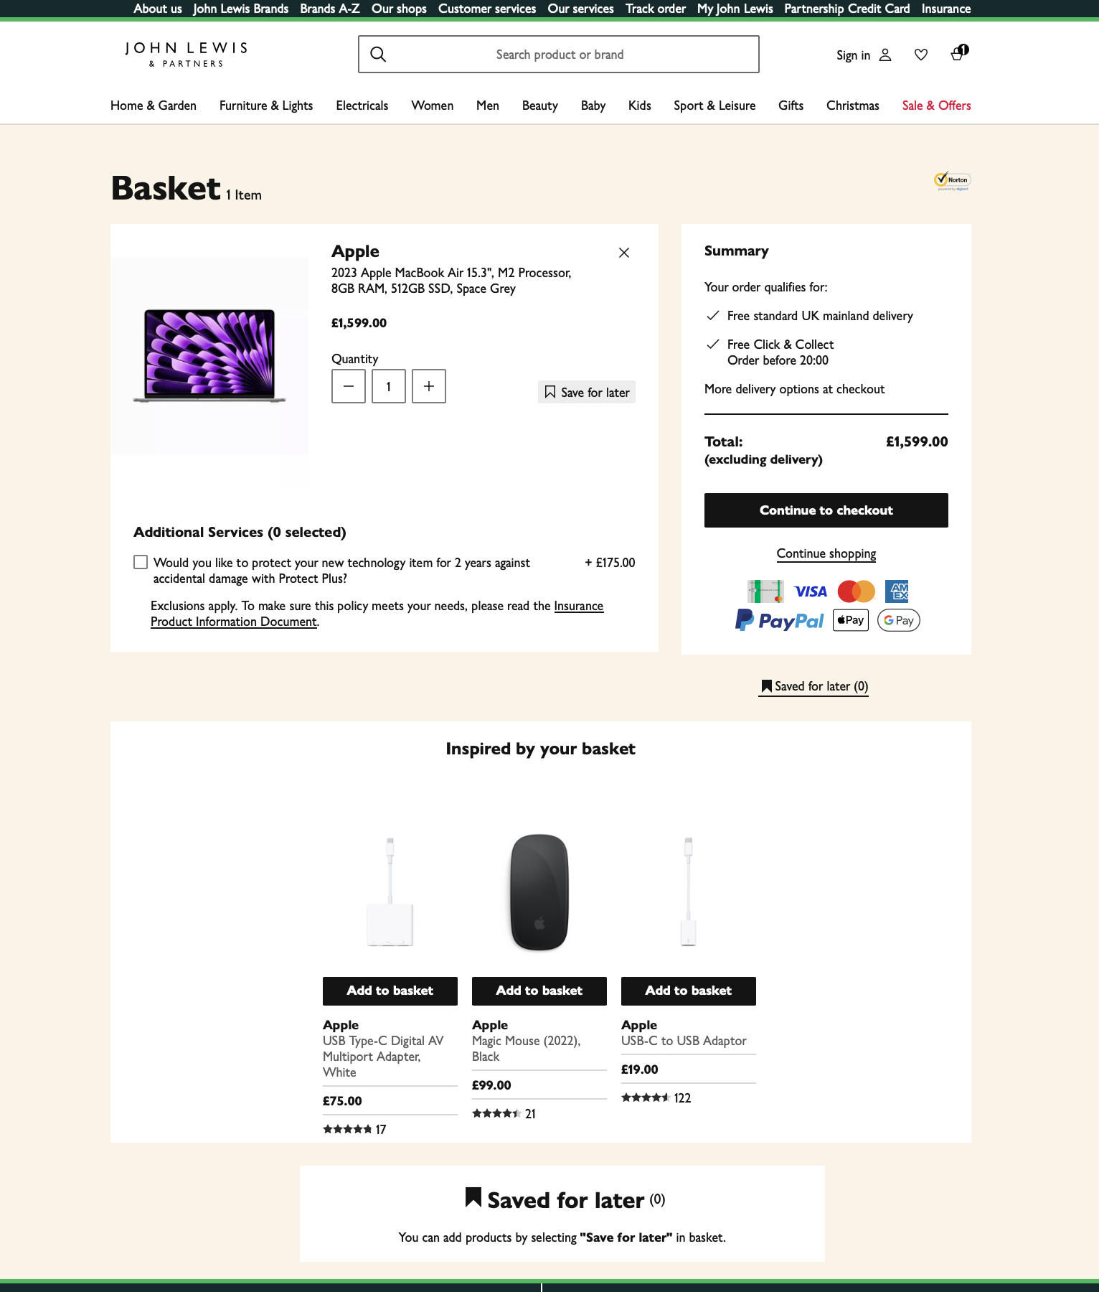

Figure 6 shows the “Basket” section of Johnlewis.co.uk website.

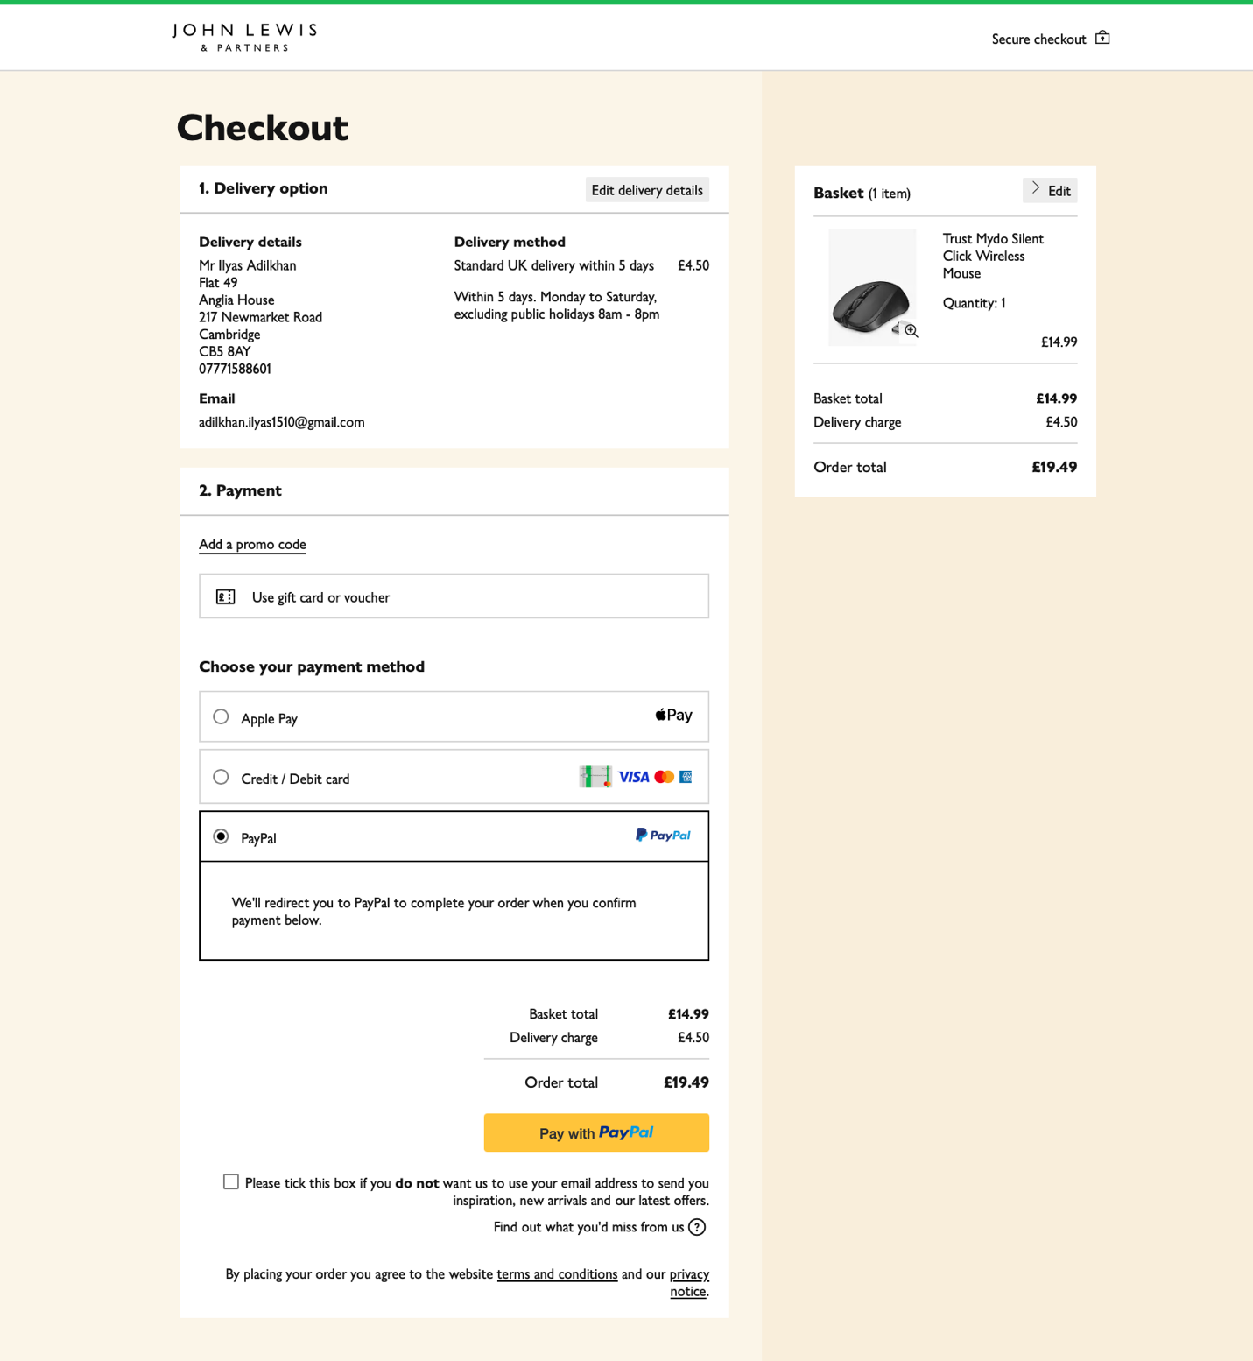

Figure 7 shows the “Checkout” section of Johnlewis.co.uk website.

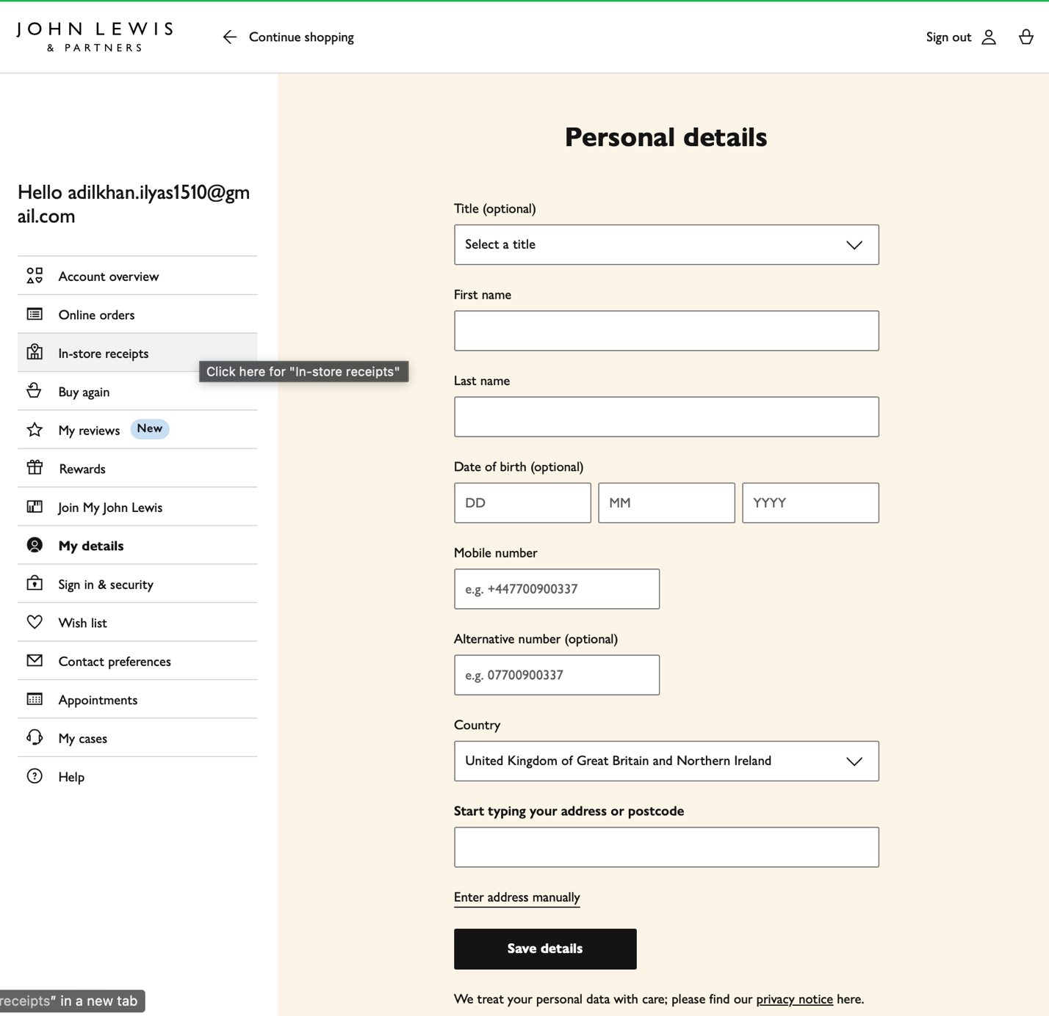

Figure 8 shows the “My details” section in “My account” section of Johnlewis.co.uk website.

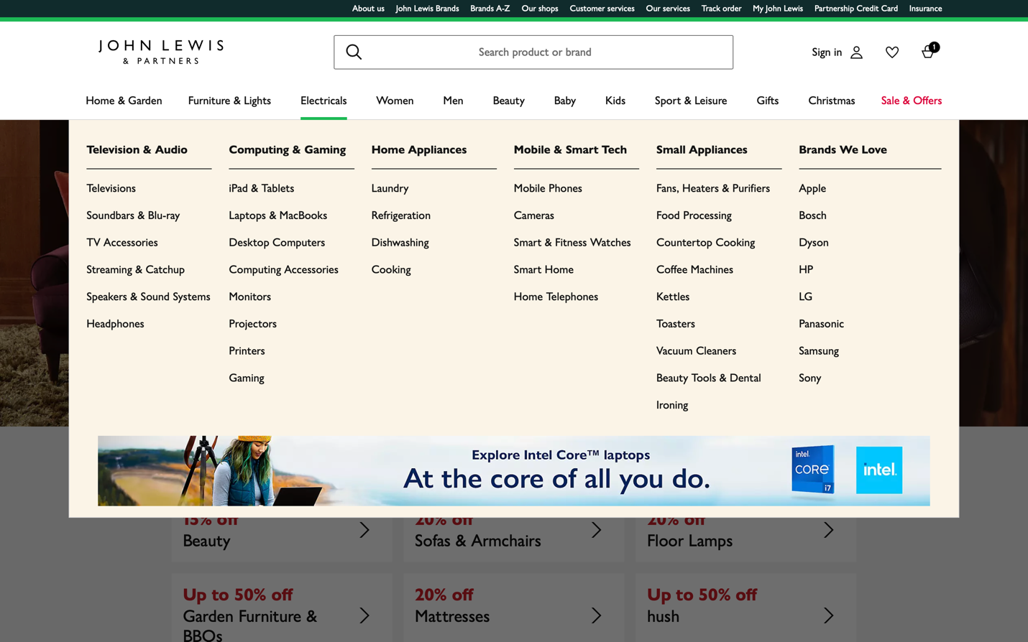

Figure 9 shows the variety of gadgets and computers in “Electricals” section of Johnlewis.co.uk website.

### List of data fields from Argos.co.uk website.

|  |  |  |  |  |
| --- | --- | --- | --- | --- |
| Customer* | Country | Customer ratings | Collection | Shipping information |
| Title* | Billing details | Special offers | Delivery | Store collection address |
| First name* | Password | Nectar points | Product | Payment method |
| Last name* | Name* | Save for later | Amount | Gift card |
| Phone number* | Price | Brand | Total price | Card number |
| House name or number | Old price | Processor type | Add item | Expiry date |
| Post code* | Color | Screen size | Delivery date | Card holder’s name |
| Address 1* | Stock | Core type | Order number | CVC |
| Address 2* | Bundle | RAM | Order date | Delivery details |
| Address 3 | insurance | Storage capacity | Invoice number |
| City* | Technical specs | Storage type | Invoice date |

After analyzing the Argos.co.uk, I have noticed that this website is more specific to the customers and products. Customers are required to give more data about themselves. The products have more discounts and offers, in addition to unique “Nectar points” of Argos.co.uk, which are collected after the purchase of product. Also, it provides 2 types of insurance for the selected products. Moreover, some of the products can be the bundles, meaning that they by default are sold with additional products such as: Microsoft 365 or protection, which is good idea.

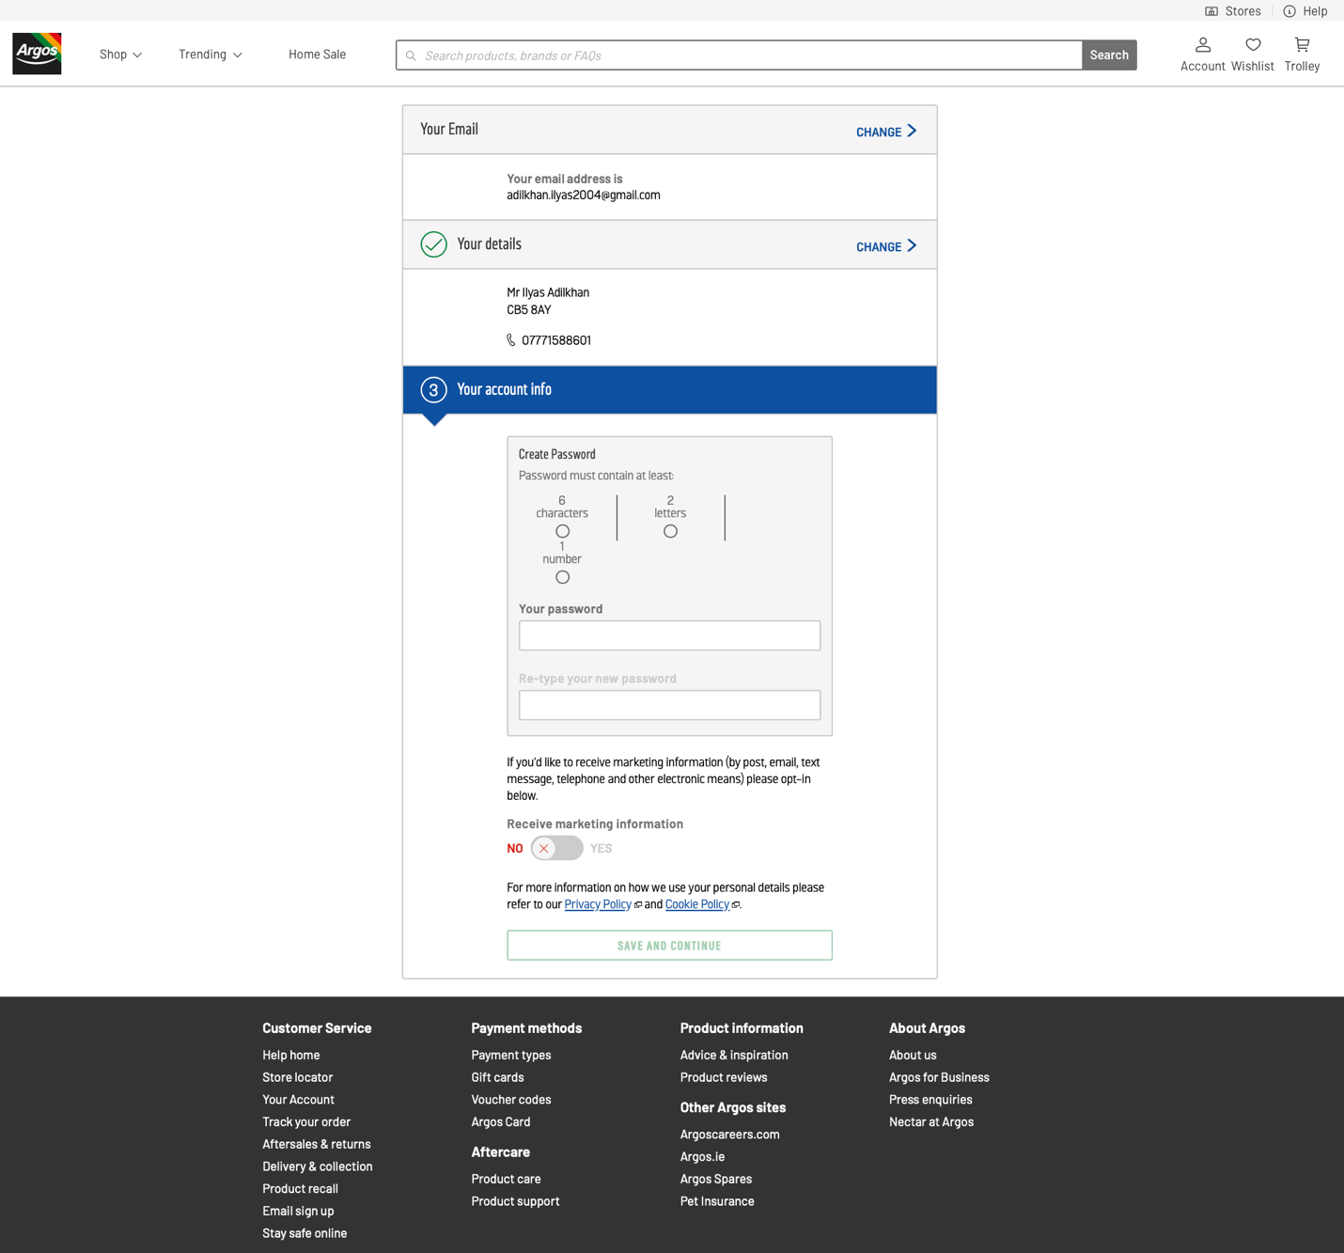

Figure 10 shows the “Registration” section of Argos.co.uk website.

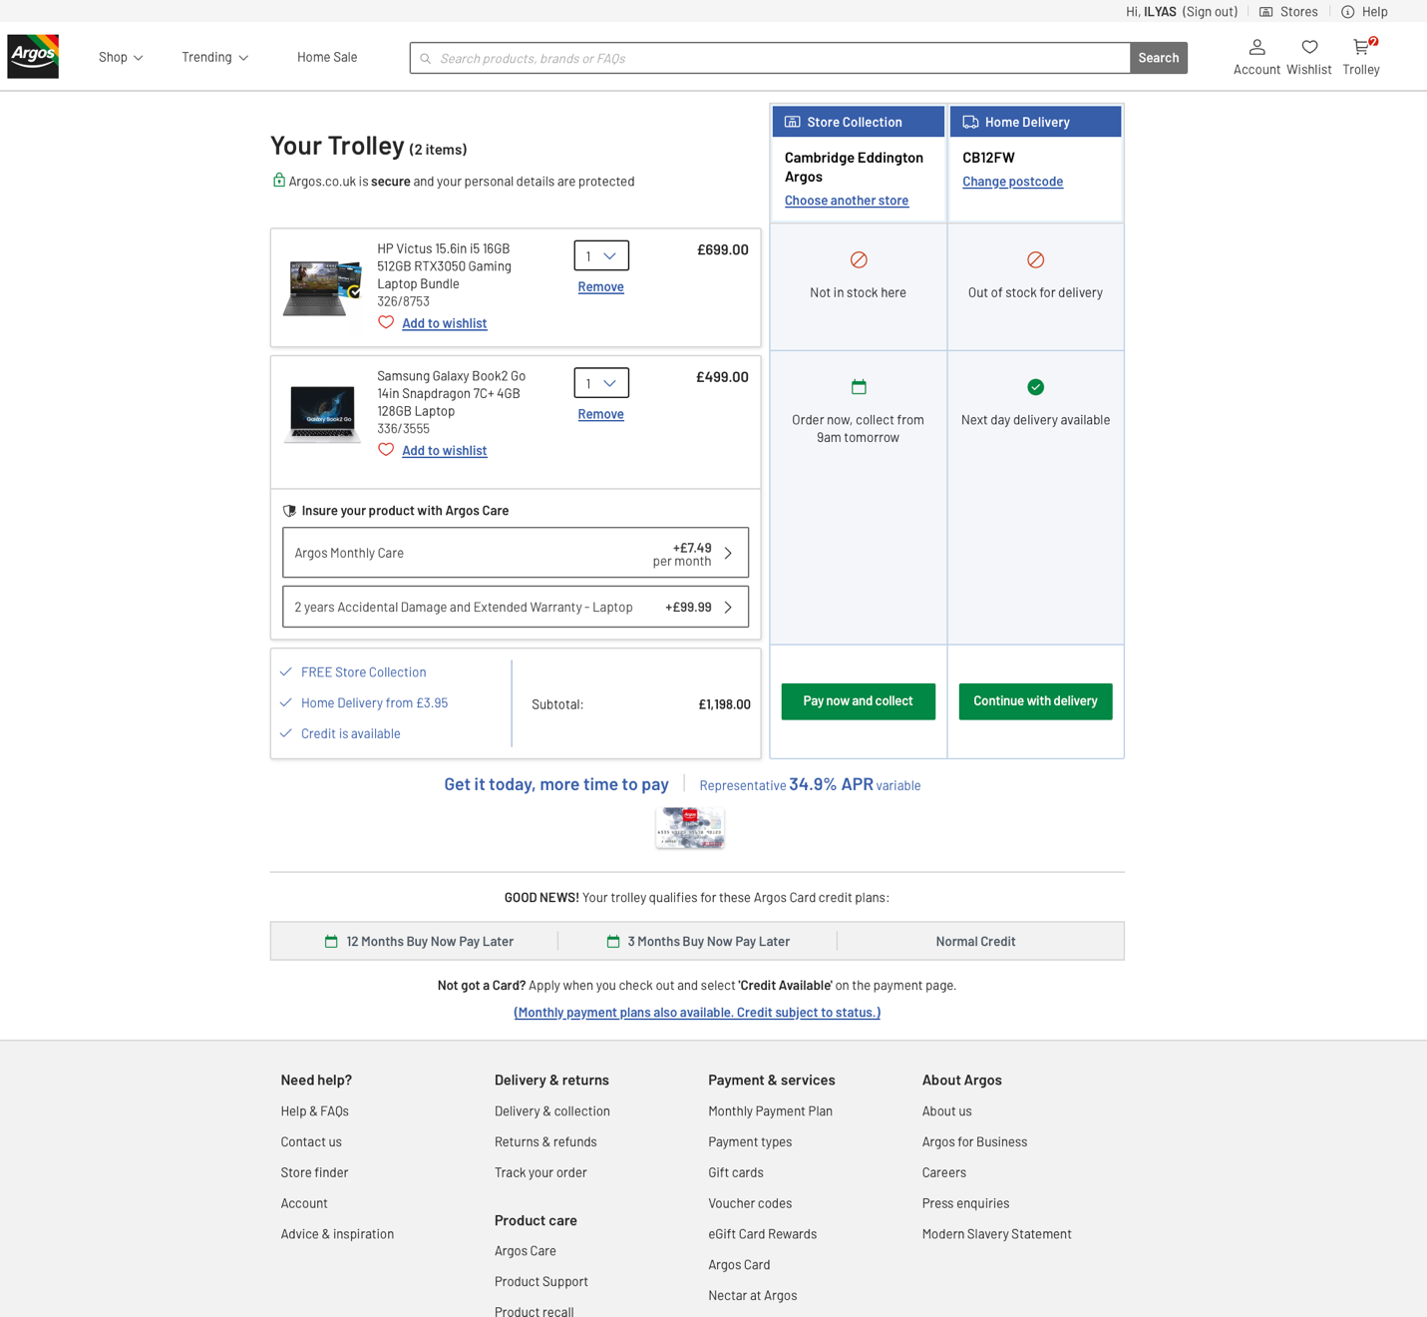

Figure 11 shows the “Trolley” section of Argos.co.uk website.

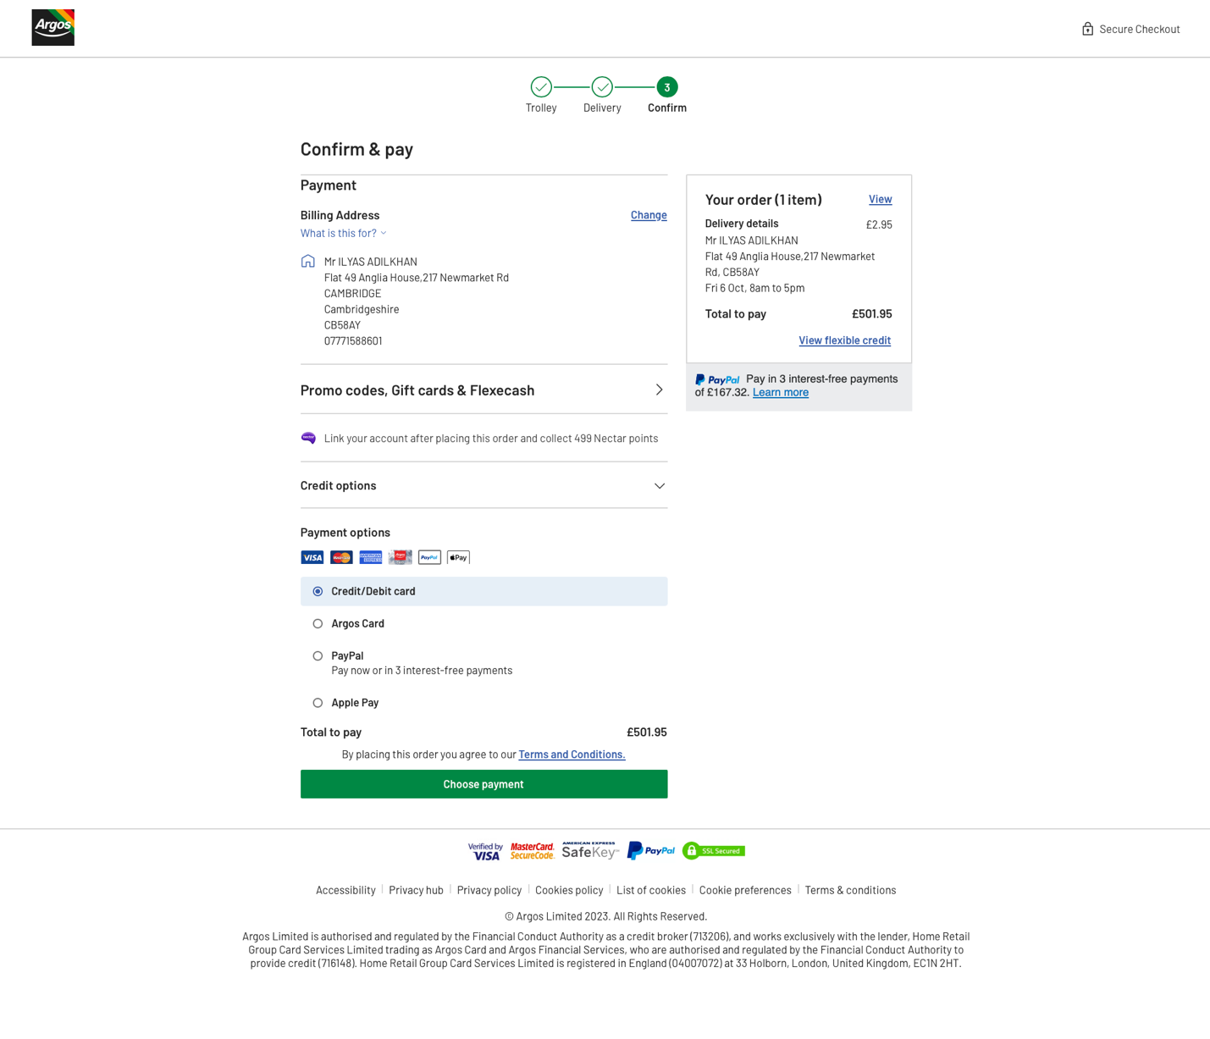

Figure 12 shows the “Confirm & pay” section of Argos.co.uk website.

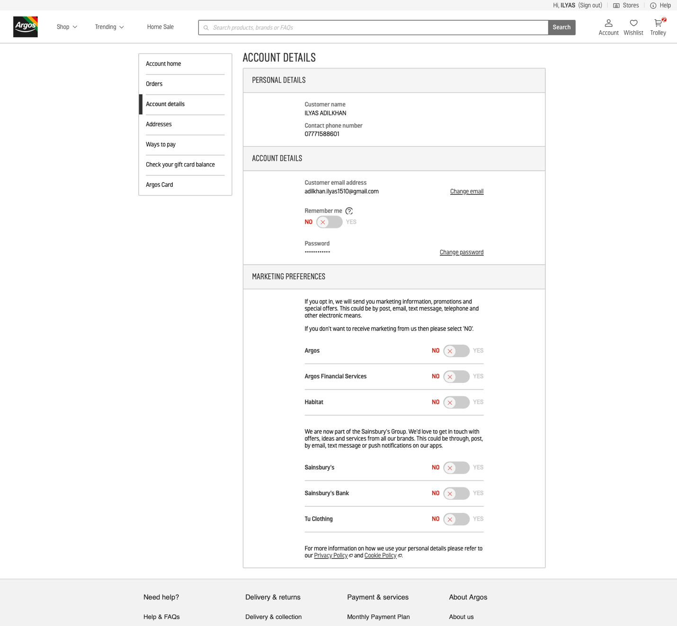

Figure 13 shows the “Account details” section of Argos.co.uk website.

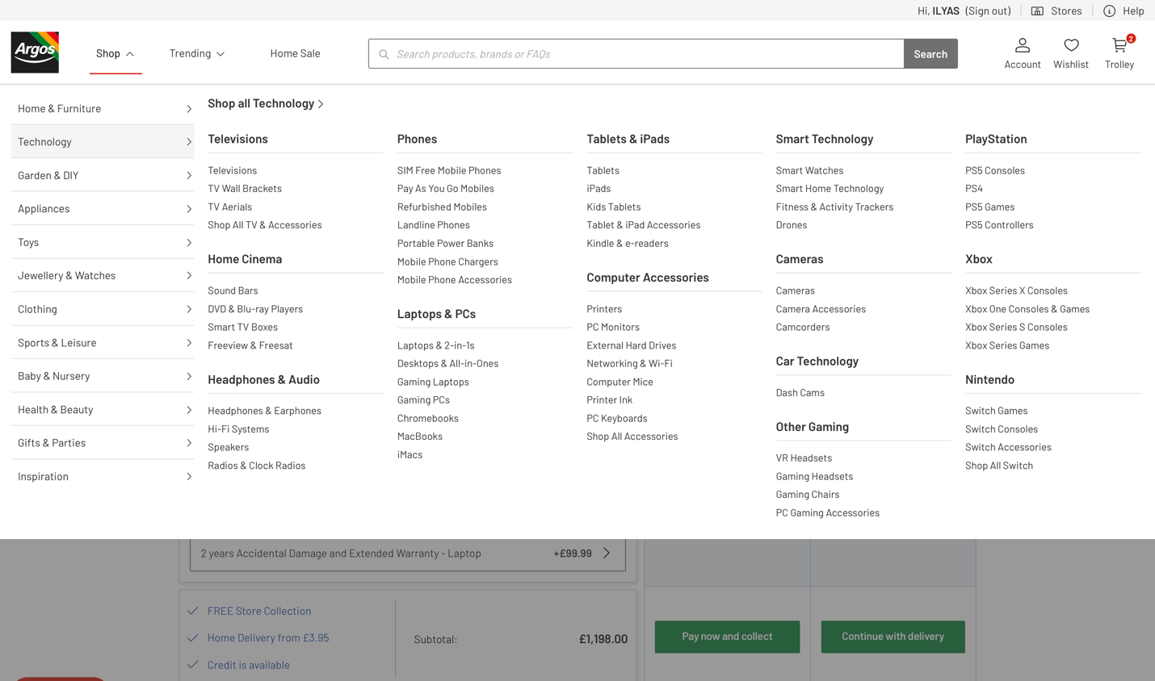

Figure 14 shows the variety of gadgets the computers in “Technology” section of Argos.co.uk website.

## **Finalized List.**

### The generic list.

This table provides the generalized list of data fields of three analyzed websites: currys.co.uk, johnlewis.co.uk, argos.cu.uk. I have added some attributes and deleted. The reasons were written in section 2.3.2 and 2.3.3

|  |  |  |  |  |
| --- | --- | --- | --- | --- |
| First_name | Address 1 | Product_average_rating | Special_feature | Invoice_date |
| Last_name | Address 2 | Special_offers | Product | Shipping_information |
| Title | DOB | Product_warranty | Amount_of_product | Send emails |
| Contact_number | Last_session_length | Category_specifications | Order_total_price | Send SMS |
| Email | Total_time_online | Processor | Way_of_getting_product | Card_number |
| Password | Product_name | Number_of_cores | Fast_or_standard_delivery | Payment_method |
| Country | Product_price | Screen_size | Delivery_address | Payment_reference |
| County | Previous_price | RAM | Pick_up_address | Amount_to_pay |
| Postcode | Product_code | Storage_capacity | Order_number |
| City | Manufacturer_code | Storage_type | Order_date |
| Billing Address | Stock | Operating_system | Invoice_number |

### New attributes and reasons of adding them.

“Last_session_length” attribute of “Customer” entity was added to observe and make statistical records of customers using the website, the same with “Total_time_online”. “County” attribute of “Customer” entity was added in order to get more information about the users and make more precise searches in the future database, for example: find users living in the Cambridshire. “Payment_reference” attribute of “Payment” entity was added to keep track of transactions.

Other attributes that may seem unfamiliar, only have been renamed. Examples: “Product_warranty” is from “Insurance”, “Category_specifications” is from “Technical_specifications” which was only for the category dependent specifications.

### Removed attributes and reasons of deleting them.

Most of the user’s card details were removed due to high risk of data leaks and a chance of data being stolen, attributes that were deleted: “Card holder’s name”, “Card verification code”, “Expiry date”.

“Order date and time” was removed, because of high frequency of changing it. It is common that delivery drivers are not able to deliver on time, because of some unexpected events or high number of parcels to be delivered.

# **Database Design.**

## **Entity Relationship Modeling.**

In the database design process, multiple models were developed. The initial ERD model in section 3.1.1 served as a simple prototype, and a more intricate EERD model was built on it. The comprehensive EERD model with extended notation is presented in section 3.1.2. After a review using normalization techniques, the final EERD model is showcased in Figure 17, Section 3.2.2.

### Initial Entity Relationship Model.

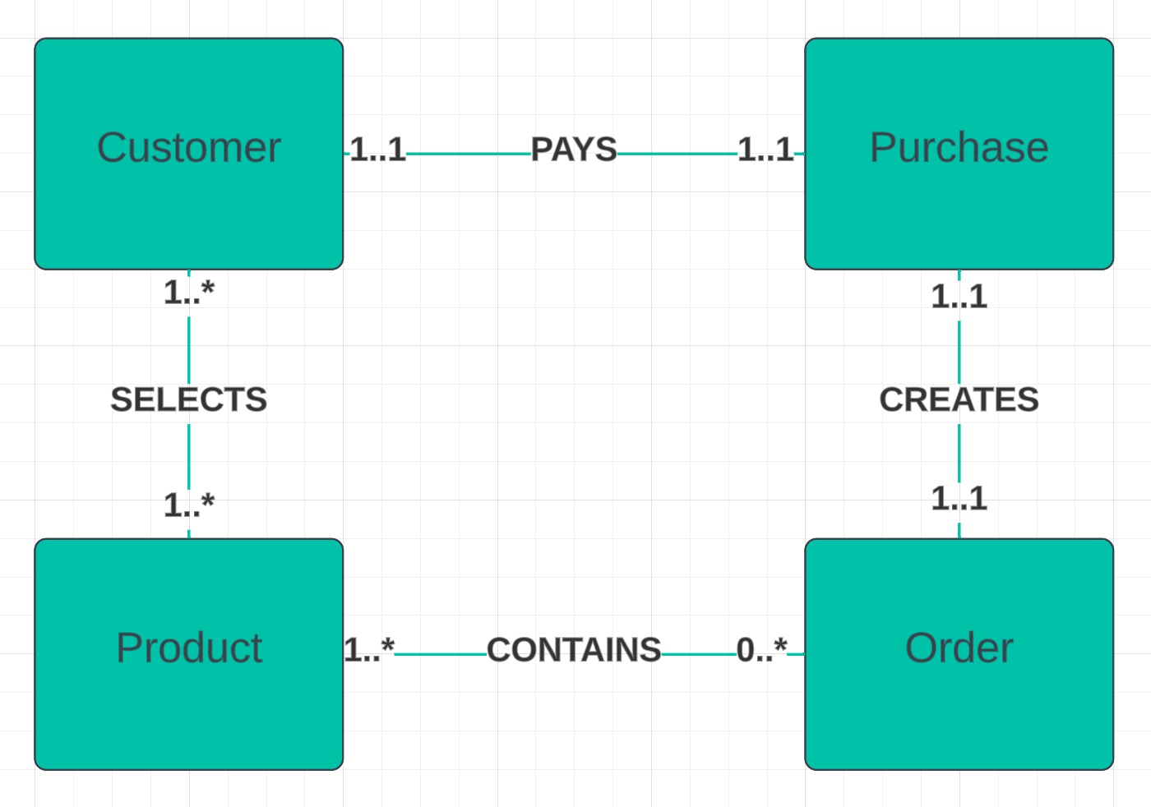

Figure 15 shows the ERD for the future Database. ERD provides the basic image of how the Database will look like, and later in the below sections will be developed into the Extended ERD model.

### Extended Entity Relationship Diagram

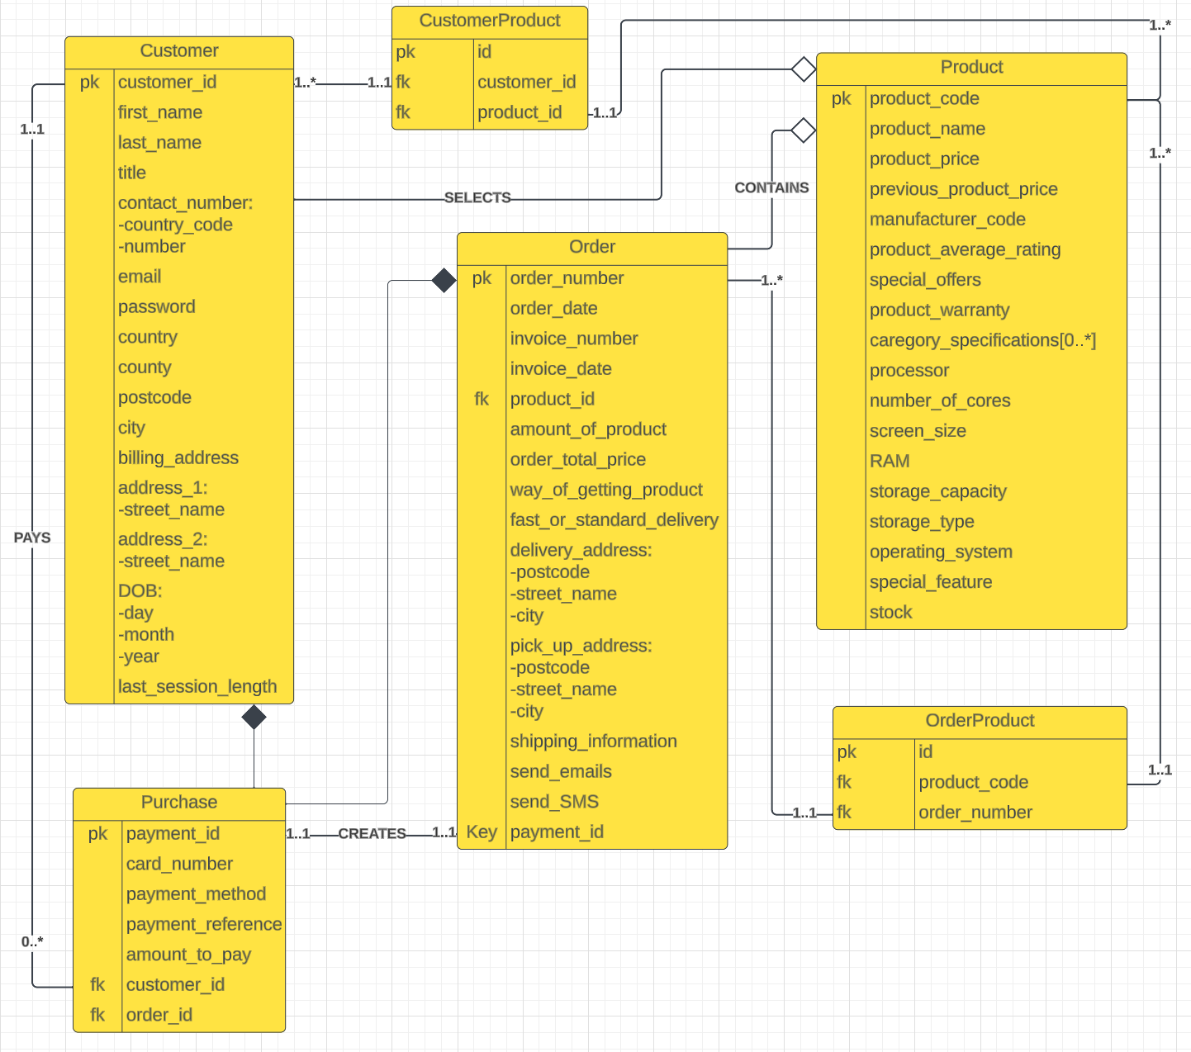

Figure 16 shows the EERD for the future database. EERD was developed from the ER model provided above. In the section 3.2.3 EERD will be finalized, refined, and normalized.

As shown in the EERD presented above:

1. Customer can select “zero-to-many” Products
2. Product can be purchased by “zero-to-many” Customers
3. Customer can make “zero-to-many” Purchases
4. Purchase can made by “one” Customer only
5. Product can be in “zero-to-many” Orders
6. Order can contain “one-to-many Products
7. Each Order creates “one” Purchase
8. Each Purchase is created by “one” Order

## **Normalized Model**

### Normalization

The initial EERD shown in Figure 16 did not pass First Normal Form (1NF). The Product table’s attribute called “category_specifications” contained multiple different values. “category_specifications” was an attribute that contained different specifications for different categories. Therefore, there were created new tables that now hold all the data that could be. Moreover, “special_offers” attribute was converted into a table called “Special_Offers”, where the product could have zero-to-one special offer. Special_Offers contains a primary key and special offer as a whole string.

1. ProductCategory table was added to solve many-to-many relationship between Product and Category tables.
2. Category table was added to hold the category names.
3. CategorySpecific_Specifications was added to hold the names of all specifications that were used.
4. Specification_Values table was added to hold the values of specificatons.

Moreover, all the composite attributes were split into the single-value attributes.

The EERD also failed the 2NF and 3NF, during the analyzation of Order table. Order table contained many attributes that were dependent on each other and independent of the primary key. Therefore, I have created a new table, called Delivery_Details that now holds all these attributes. Moreover, when analyzing Purchase table, ‘amount_to_pay’ was the same attribute as ‘order_total_price’ in Order table. Therefore, I have decided to remove ‘amount_to_pay’ attribute.

### Normalized EERD model

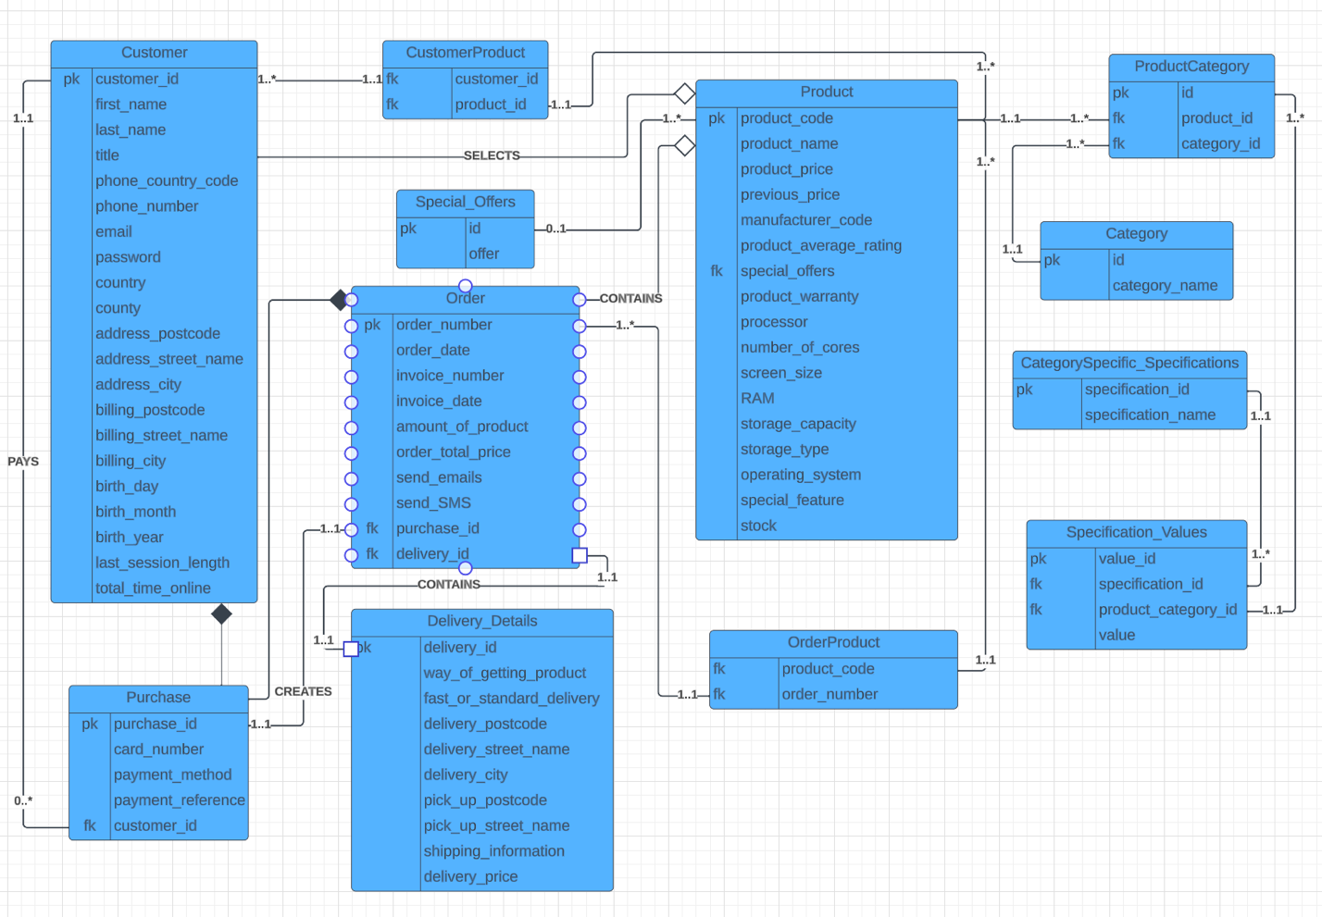

Figure 17 shows the Normalized EERD model.

## **Database Schema**

The database consists of twelve tables:

1. Customer
2. CustomerProduct
3. Purchase
4. Special_Offers
5. Order
6. Deliver_Details
7. Product
8. OrderProduct
9. ProductCategory
10. Category
11. Category_Specific_Specifications
12. Specification_Values

|  |  |  |  |
| --- | --- | --- | --- |
| **Customer** | | | |
| Attribute name | Data type | Allow Nulls | Description |
| customer_id | int | NO | Primary key, autoincremented, unique |
| first_name | char(20) | NO | Stores customer’s first name |
| last_name | char(20) | NO | Stores customer’s last name |
| title | enum('Mr',Ms','Mrs','Dr') | NO | Stores customer’s title |
| phone_country_code | varchar(10) | YES | Stores the phone’s country code, varchar because country code contains “+”, which is not integer data type |
| phone_number | int | YES | Stores customer’s phone number |
| email | varchar(50) | NO | Stores customer’s email |
| password | varchar(255) | NO | Stores customer’s password, varchar, because password must be alphanumerical, 255 – to accommodate hashed passwords |
| country | char(20) | NO | Stores customer’s country name |
| county | char(50) | NO | Stores customer’s county name |
| address_postcode | varchar(50) | NO | Stores customer’s address postcode |
| address_street_name | varchar(50) | NO | Stores customer’s street name |
| address_city | char(20) | NO | Stores customer’s city name |
| billing_postcode | varchar(50) | NO | Stores customer’s billing post code |
| billing_street_name | varchar(50) | NO | Stores customer’s billing street name |
| billing_city | varchar(20) | NO | Stores customer’s billing city name |
| birth_day | int | YES | Stores customer’s birth day |
| birth_month | int | YES | Stores customer’s birth month |
| birth_year | int | YES | Stores customer’s birth year |
| last_session_length | time | YES | Stores customer’s last session length |
| total_time_online | time | YES | Stores customer’s total time online |

|  |  |  |  |
| --- | --- | --- | --- |
| **CustomerProduct** | | | |
| Attribute name | Data type | Allow Nulls | Description |
| customer_id | int | NO | Foreign key, Stores primary key of Customer table |
| product_id | int | NO | Foreign key, Stores primary key of Product table |

|  |  |  |  |
| --- | --- | --- | --- |
| **Purchase** | | | |
| Attribute name | Data type | Allow Nulls | Description |
| purchase_id | int | NO | Primary key, autoincremented, unique |
| card_number | int | YES | Stores the card number of a purchase |
| payment_method | varchar(20) | YES | Stores the payment method of a purchase |
| payment_reference | varchar(100) | YES | Stores the payment reference of a purchase |
| customer_id | int | NO | Foreign key, stores a primary key of a Customer table |

|  |  |  |  |
| --- | --- | --- | --- |
| **Special Offers** | | | |
| Attribute name | Data type | Allow Nulls | Description |
| id | int | NO | Primary key, autoincremented, unique |
| offer | text | YES | Stores the text of an offer |

|  |  |  |  |
| --- | --- | --- | --- |
| **Order** | | | |
| Attribute name | Data type | Allow Nulls | Description |
| order_number | int | NO | Primary key, autoincremented, unique |
| order_date | date | NO | Stores the order’s date |
| invoice_number | int | NO | Stores an invoice number of the order |
| invoice_date | date | NO | Stores the invoice’s date |
| amount_of_product | int | NO | Stores the amount of product in an order |
| order_total_price | int | NO | Stores the total price of the order |
| send_emails | boolean | YES | Stores the Boolean value of sending emails or not |
| send_sms | boolean | YES | Stores the Boolean value of sending SMSs or not |
| purchase_id | int | NO | Foreign key, stores a primary key of Purchase table |
| delivery_id | int | NO | Foreign key, stores a primary key of Delivery_Details table |

|  |  |  |  |
| --- | --- | --- | --- |
| **Delivery_Details** | | | |
| Attribute name | Data type | Allow Nulls | Description |
| delivery_id | int | NO | Primary key, autoincremented, unique |
| way_of_getting_product | char(10) | NO | Stores either two ways of getting a product: “delivery” or “pickup” |
| fast_or_standard_delivery | enum(‘fast’, ’standard’) | NO | Stores either “fast” or “standard” delivery (if “fast” delivery, then backend should add additional price to total price) |
| delivery_postcode | varchar(20) | YES | Stores a postcode of the delivery address |
| deliver_street_name | varchar(50) | YES | Stores a street name of the delivery address |
| delivery_city | char(20) | YES | Stores a name of city of the delivery address |
| pick_up_postcode | varchar(20) | YES | Stores a postcode of the pick-up address |
| pick_up_street_name | varchar(20) | YES | Stores a street name of the pick-up address |
| shipping_information | text | NO | Stores the shipping information as a text (summary of whole delivery details, made in backend, sent to a user) |
| delivery_price | float | YES | Stores the delivery price, can be NULL because customer may choose to pick up a parcel |

|  |  |  |  |
| --- | --- | --- | --- |
| **Product** | | | |
| Attribute name | Data type | Allow Nulls | Description |
| product_code | int | NO | Primary key, autoincremented, unique |
| product_name | varchar(50) | NO | Stores the product’s name |
| product_price | int | NO | Stores the product’s price |
| previous_price | int | YES | Stores the product’s previous price |
| manufacturer_code | int | NO | Stores the product’s manufacturer code |
| product_average_rating | float | YES | Stores the product’s average rating |
| special_offers | int | YES | Foreign key, stores the primary key of Special_Offers table |
| product_warranty | text | YES | Stores the product’s warranty information as a text |
| processor | varchar(20) | NO | Stores the product’s processor name |
| number_of_cores | int | NO | Stores the product’s processor’s number of cores |
| screen_size | float | NO | Stores the product’s screen size |
| ram | int | NO | Stores the product’s random-access memory |
| storage_capacity | int | NO | Stores the product’s storage capacity |
| storage_type | varchar(20) | NO | Stores the product’s storage type |
| operating_system | varchar(20) | NO | Stores the product’s operating system name |
| special_feature | text | YES | Stores the product’s special feature as a text describing it |
| stock | int | NO | Stores the product’s stock (amount of the product) |

|  |  |  |  |
| --- | --- | --- | --- |
| **OrderProduct** | | | |
| Attribute name | Data type | Allow Nulls | Description |
| product_code | int | NO | Foreign key, stores the primary key of the Product table |
| order_number | int | NO | Foreign key, stores the primary key of the Order table |

|  |  |  |  |
| --- | --- | --- | --- |
| **ProductCategory** | | | |
| Attribute name | Data type | Allow Nulls | Description |
| id | int | NO | Primary key, autoincremented, unique |
| product_id | int | NO | Foreign key, stores the primary key of the Product table |
| category_id | int | NO | Foreign key, stores the primary key of the Category table |

|  |  |  |  |
| --- | --- | --- | --- |
| **Category** | | | |
| Attribute name | Data type | Allow Nulls | Description |
| id | int | NO | Primary key, autoincremented, unique |
| category_name | varchar(20) | NO | Stores the category name |

|  |  |  |  |
| --- | --- | --- | --- |
| **CategorySpecific_Specifications** | | | |
| Attribute name | Data type | Allow Nulls | Description |
| id | int | NO | Primary key, autoincremented, unique |
| specification_name | varchar(20) | NO | Stores the specification name |

|  |  |  |  |
| --- | --- | --- | --- |
| **Specification_Values** | | | |
| Attribute name | Data type | Allow Nulls | Description |
| value_id | int | NO | Primary key, autoincremented, unique |
| specification_id | int | NO | Foreign key, stores the Primary key of the CategorySpecific_Specifications table |
| product_category_id | int | NO | Foreign key, stores the Primary key of the ProductCategory table |
| value | varchar(50) | NO | Stores the value of a specification |

# **4 Database Implementation**

The Database Implementation process provided below was done using XAMPP for OS X version 8.2.4. The examples of data were generated using ChatGPT version 4.

In the Figure 18 below you can see all tables with the provided data such as: storage type, amount of rows, collation and size.

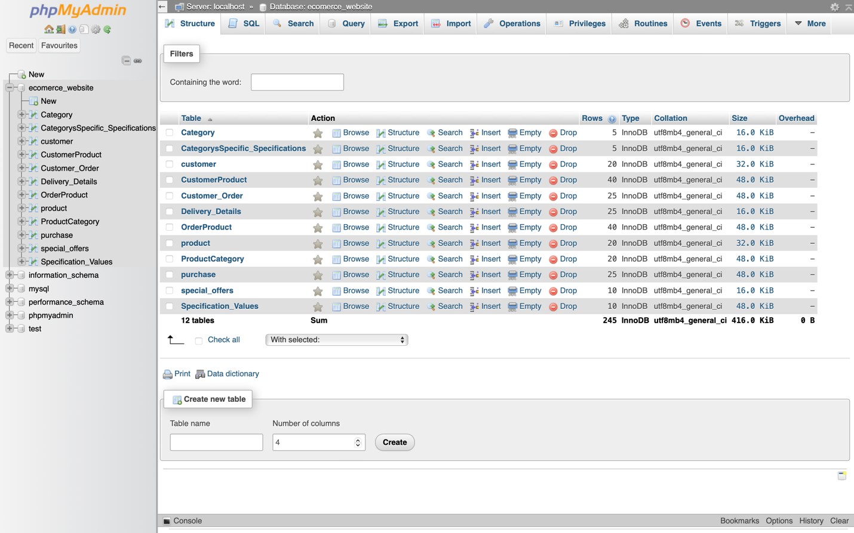

Figure 18 List of Implemented tables

Some tables contain less rows than required. The main reason is, that these tables store only descriptive data, such as: special offers or category names.

The screenshots below, will show the SQL queries for all tables in a database. Each screenshot includes two queries: CREATE TABLE and INSERT INTO. I have also provided some comments.

## Customer table implementation

20 rows were inserted

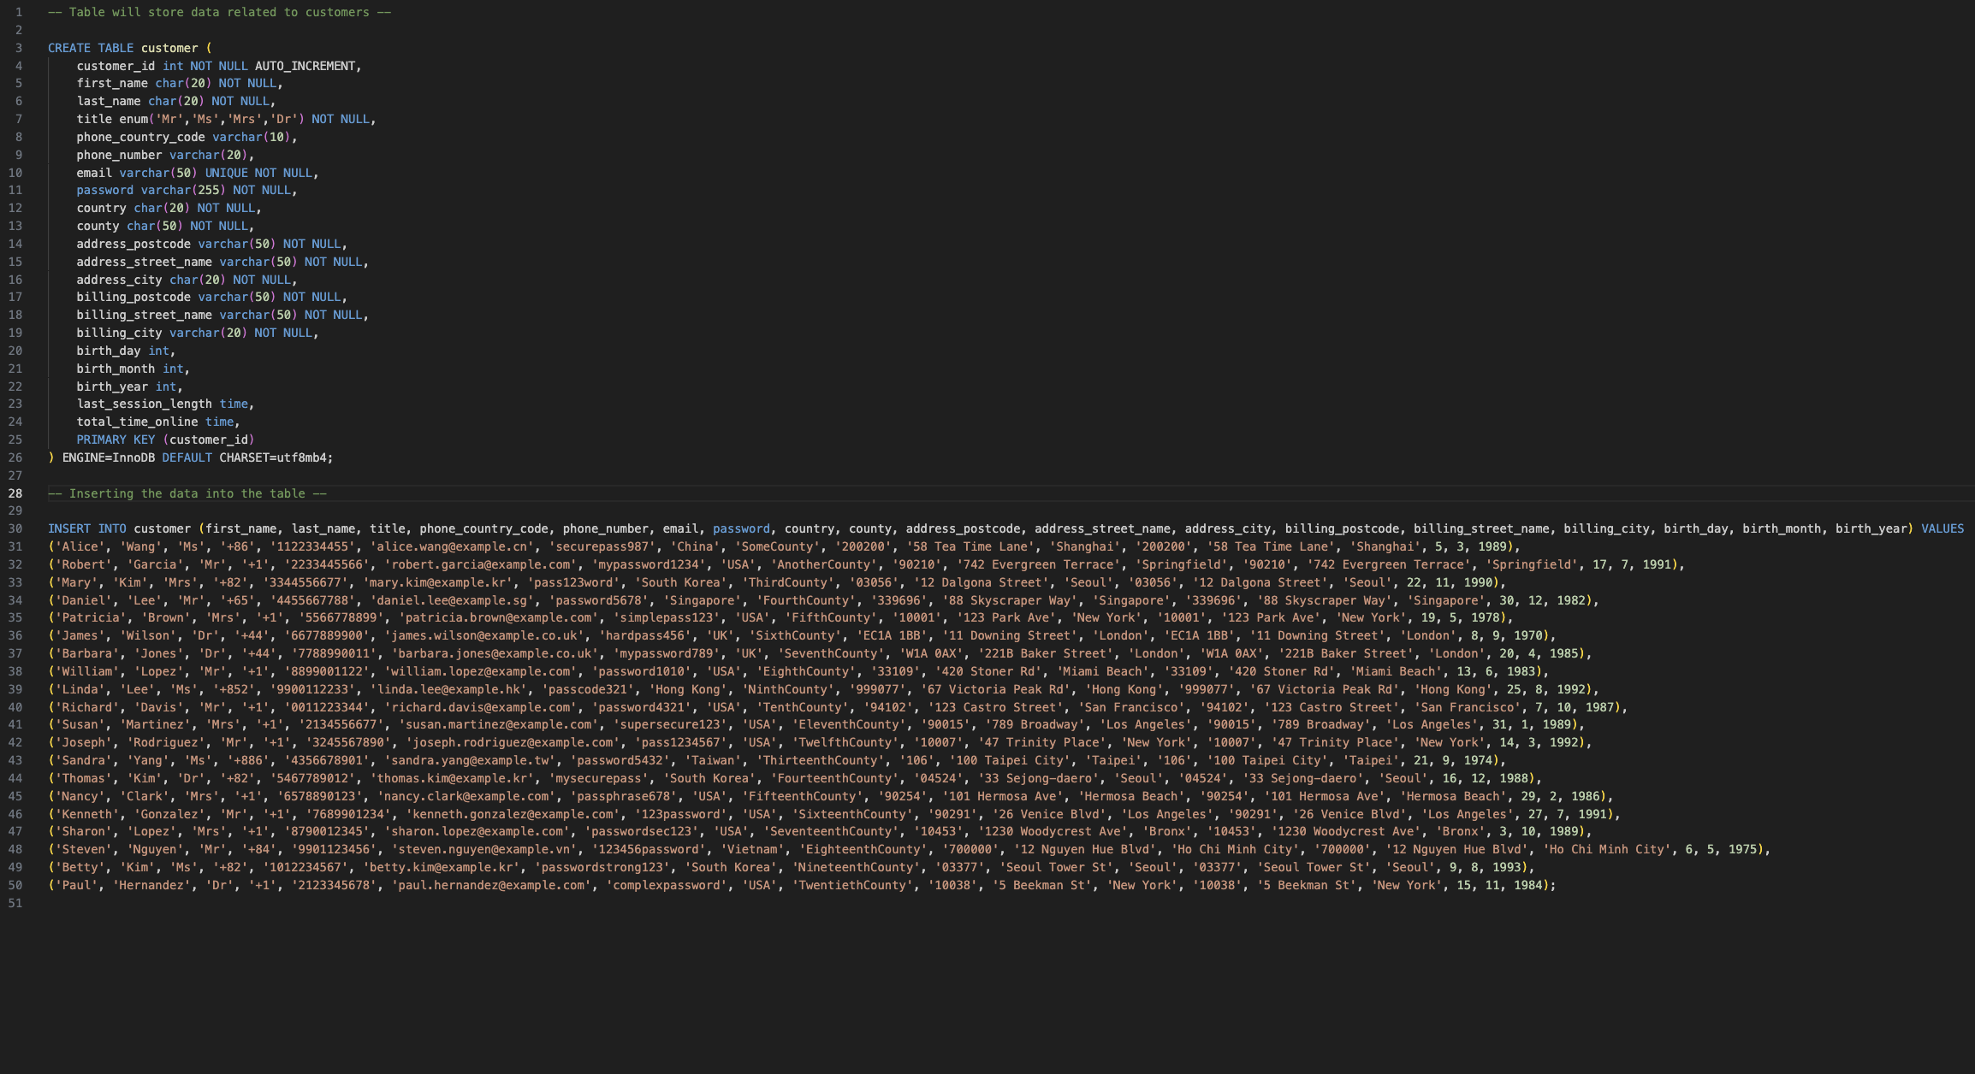

Last two columns were inserted manually.

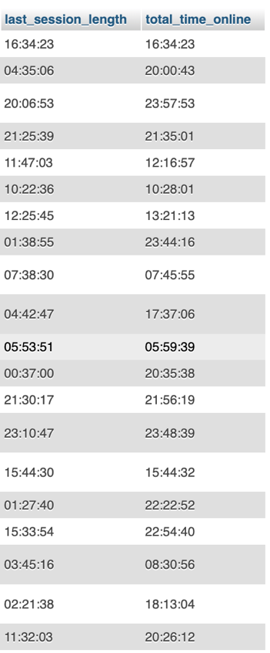

## Purchase table implementation

25 rows were inserted

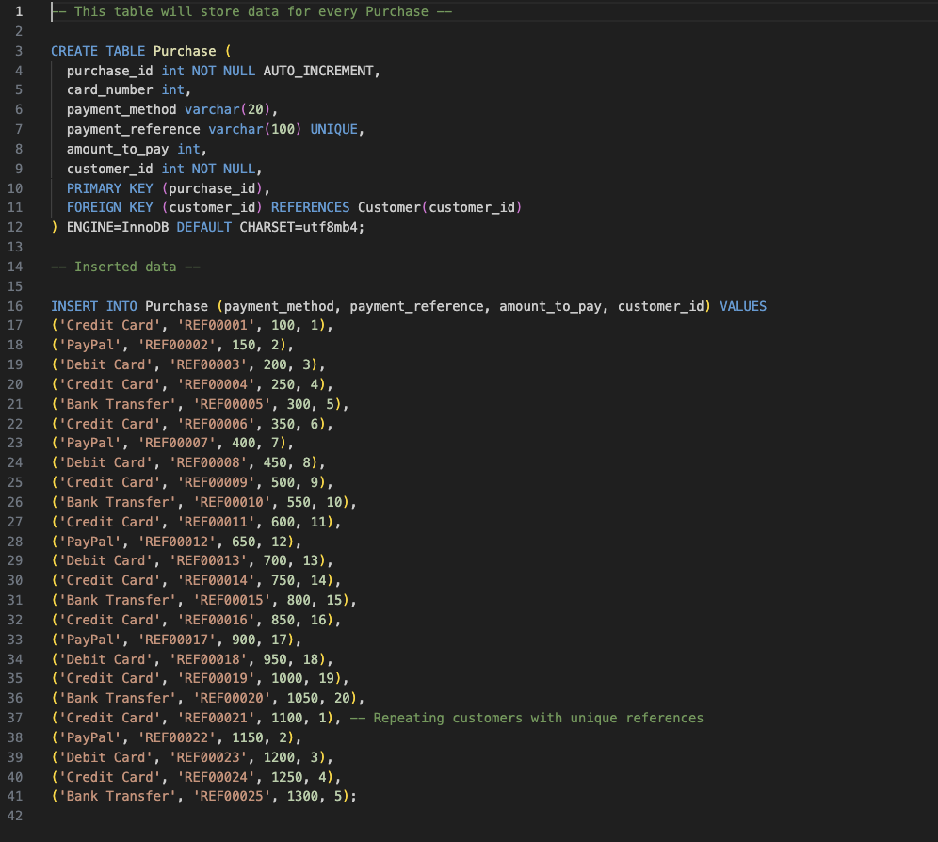

## Product table implementation

20 rows were inserted

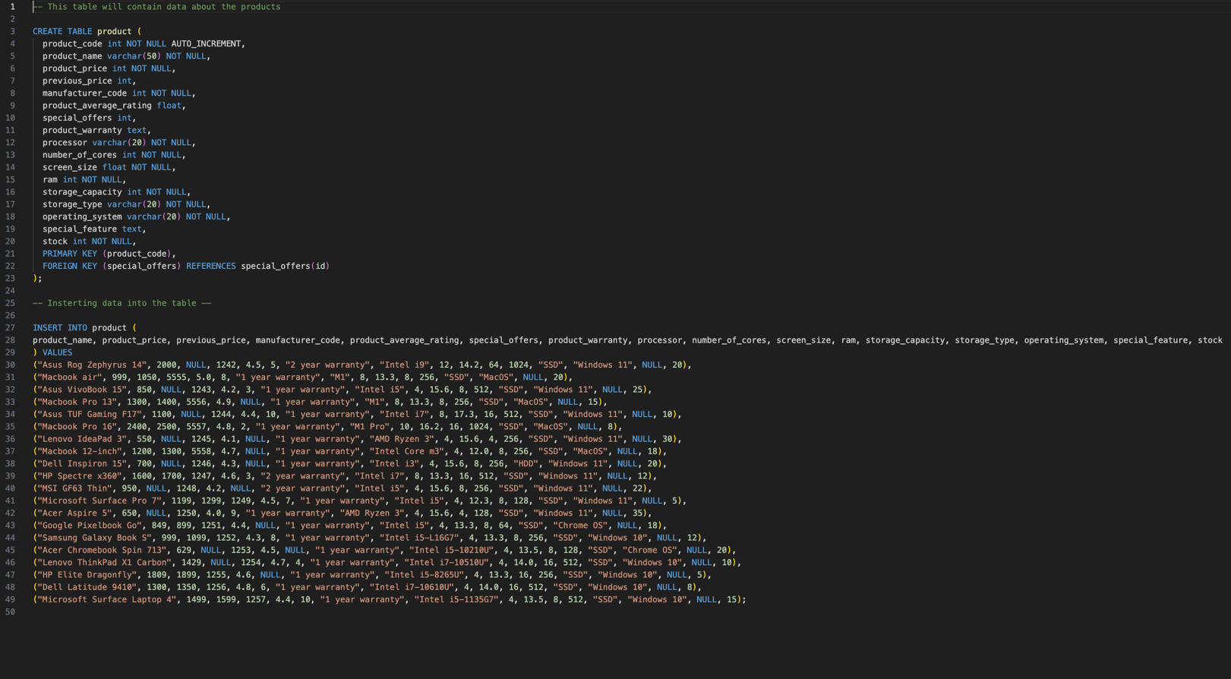

special_feature column was filled with data manually.

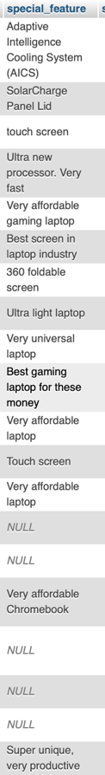

## 4.5 Special_Offers table implementation

1. rows were inserted

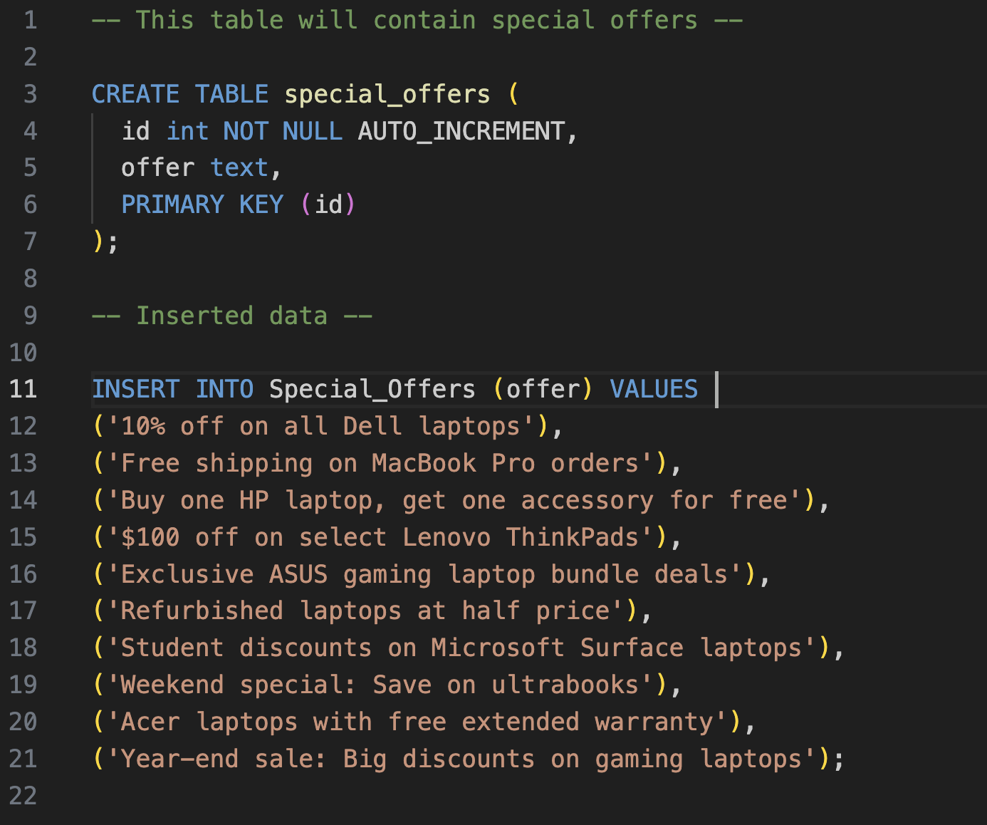

## 4.6 CustomerProduct table implementation

40 rows were inserted

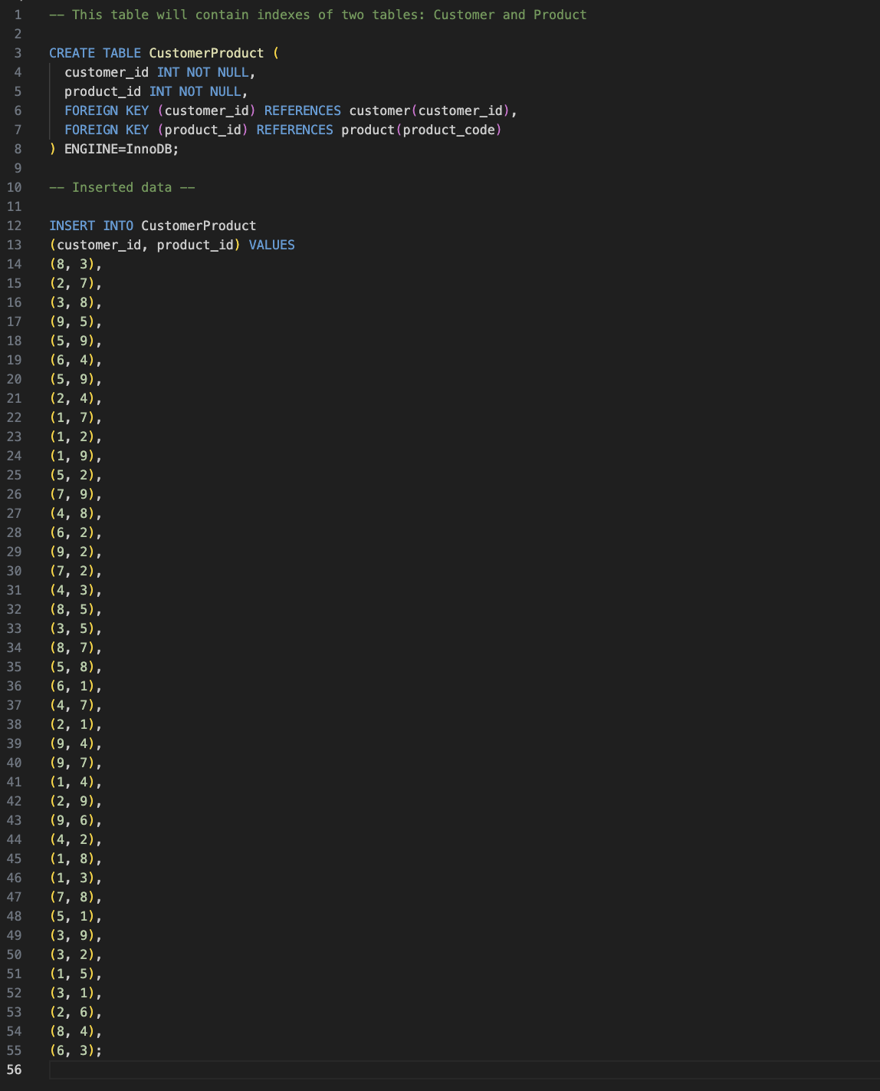

## 4.7 Order table implementation

25 rows were inserted

The name of table has been changed, because it was taking the keyword “ORDER”

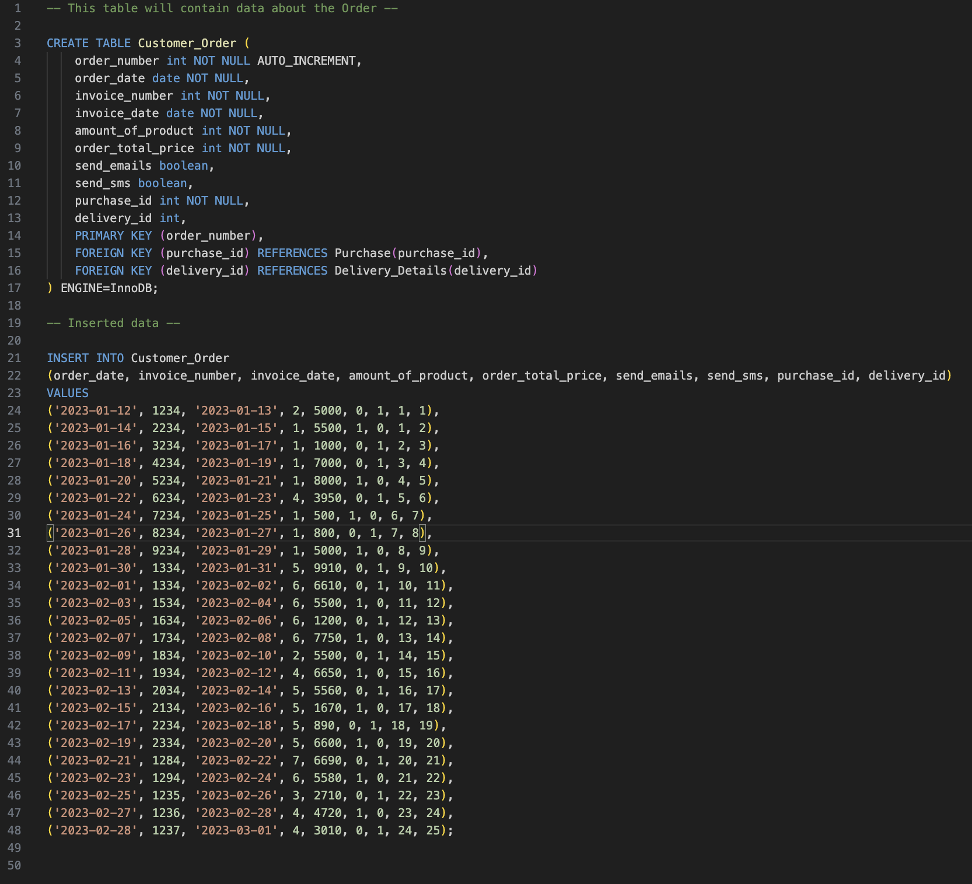

## 4.8 Delivery_Details table implementation

25 rows were inserted

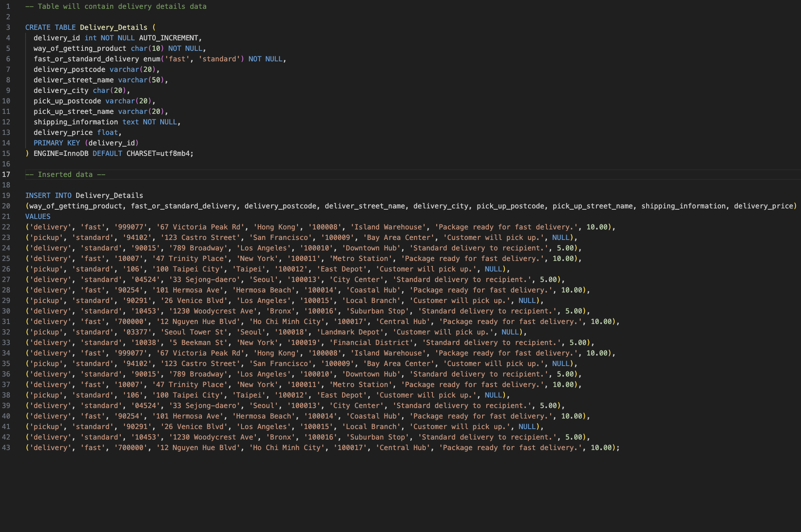

## 4.9 OrderProduct table implementation

40 rows were inserted

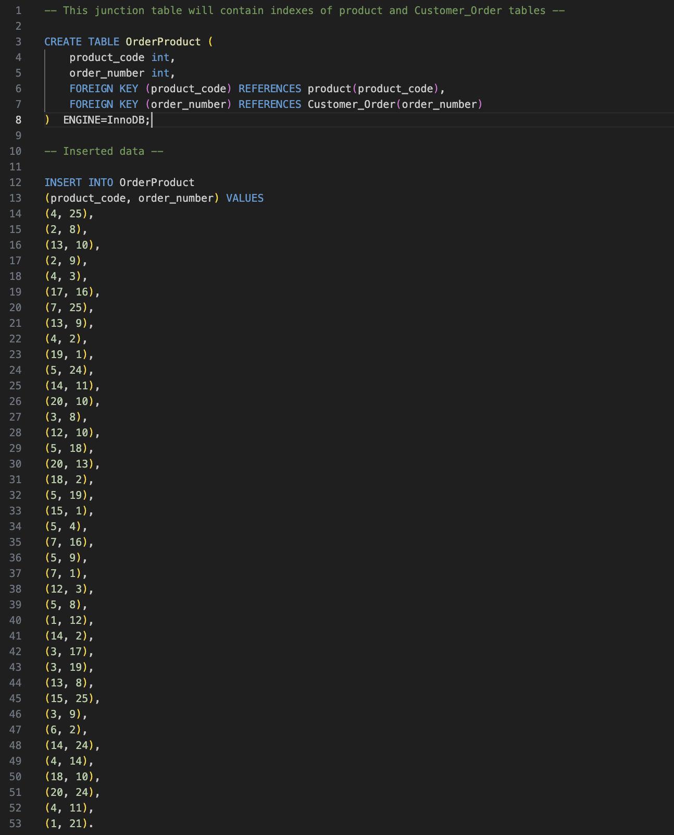

## 4.10 Category table implementation

5 rows were inserted

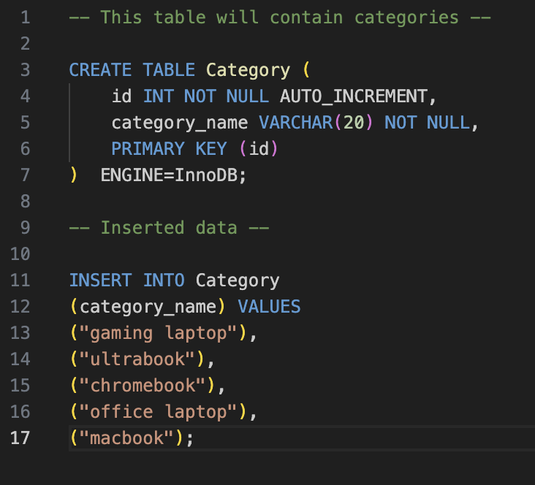

## 4.11 ProductCategory table implementation

20 rows were inserted

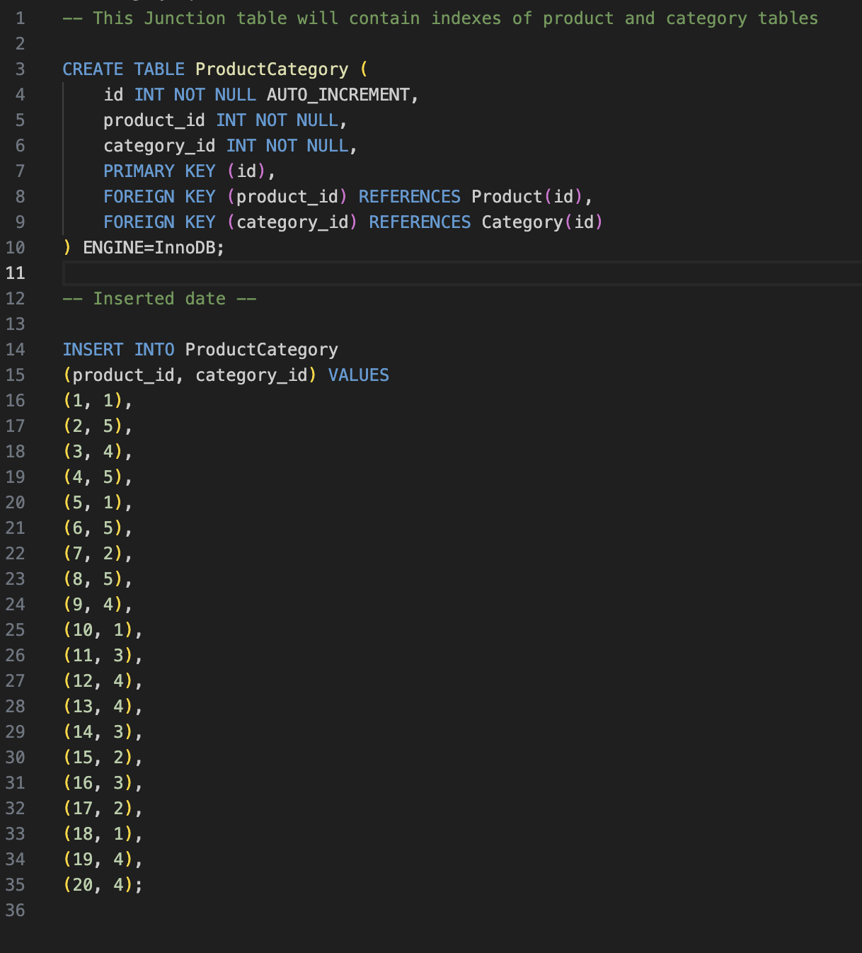

## 4.12 CategorySpecific_Specifications table implementation

5 rows were inserted

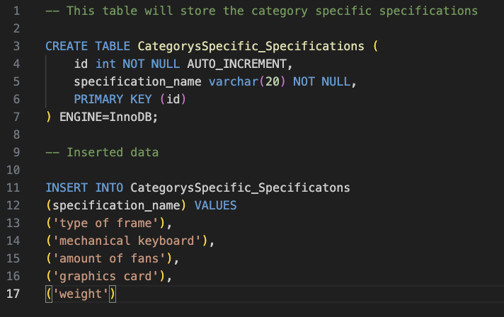

## 4.13 Specification_Values table implementation

10 rows were inserted

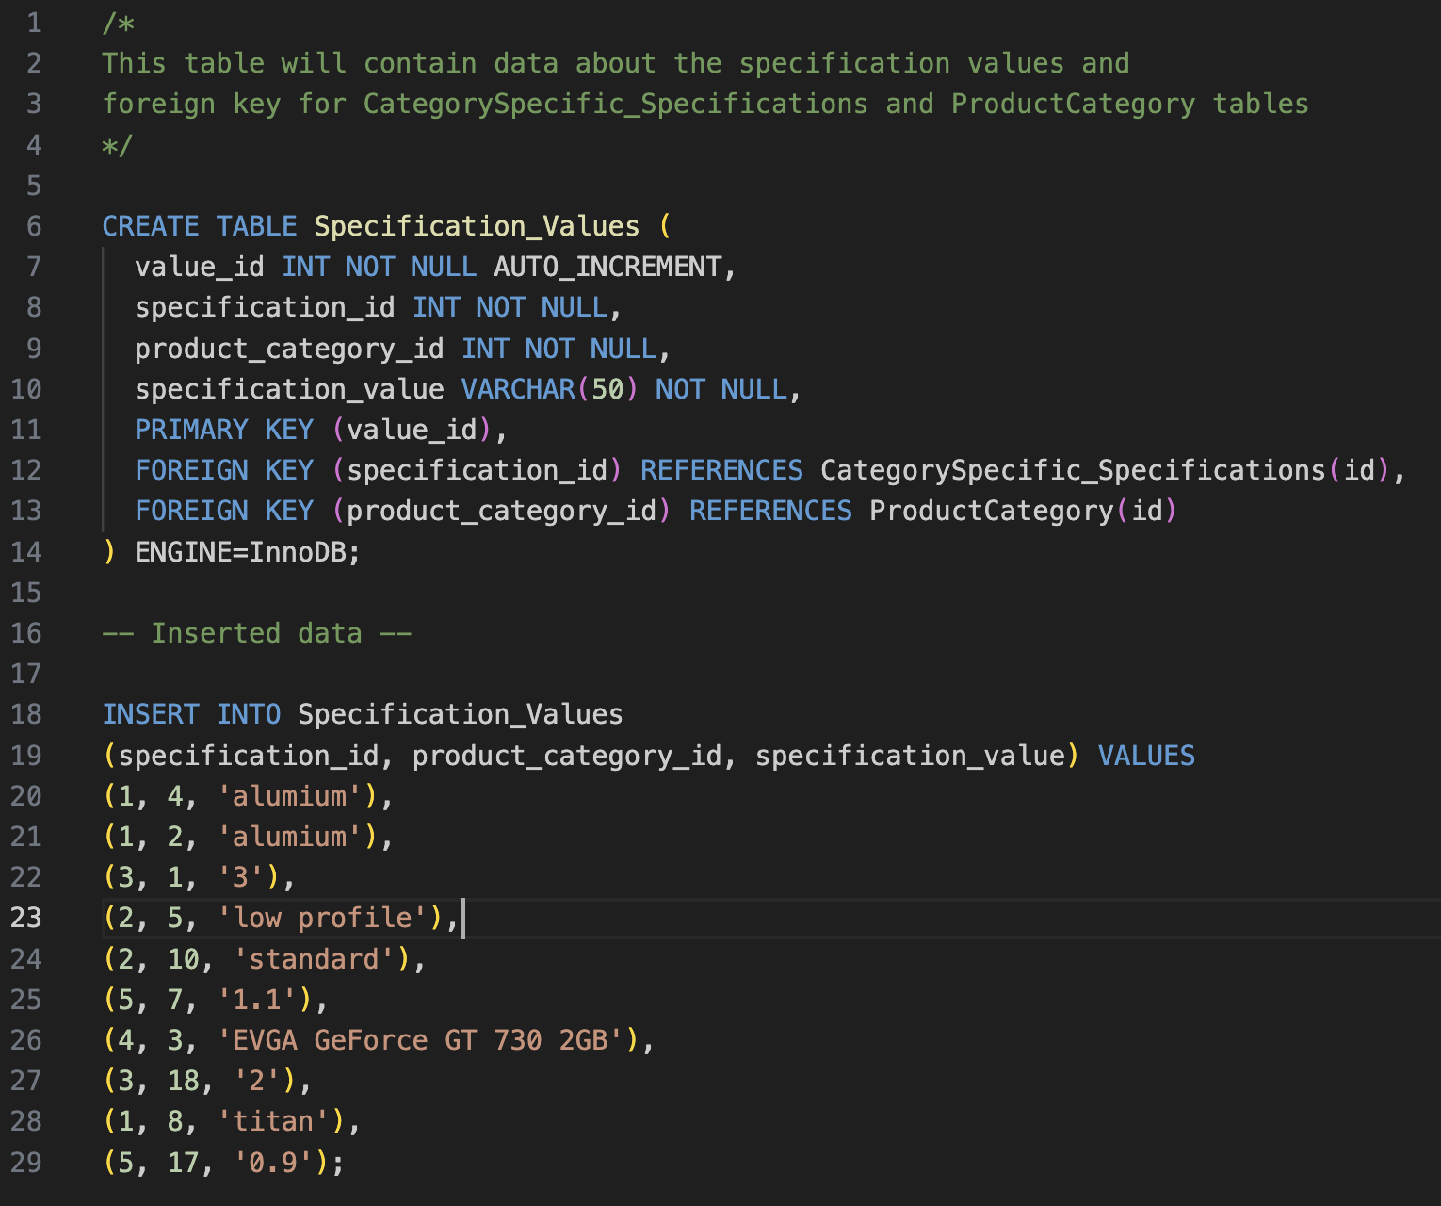

# **5 SQL Queries**

## **5.1 Query 1**

### 5.1.1 Business purpose

As a Database Administrator, I aim to develop a stored procedure for updating Order totals, ensuring data integrity by restricting direct record modifications by Web Developers.

### 5.1.2 Query in natural language

Display product name, product price, category name, specification name and specification value. Show only office and gaming laptops and order everything by product price in descending order.

### 5.1.3 SQL code and output

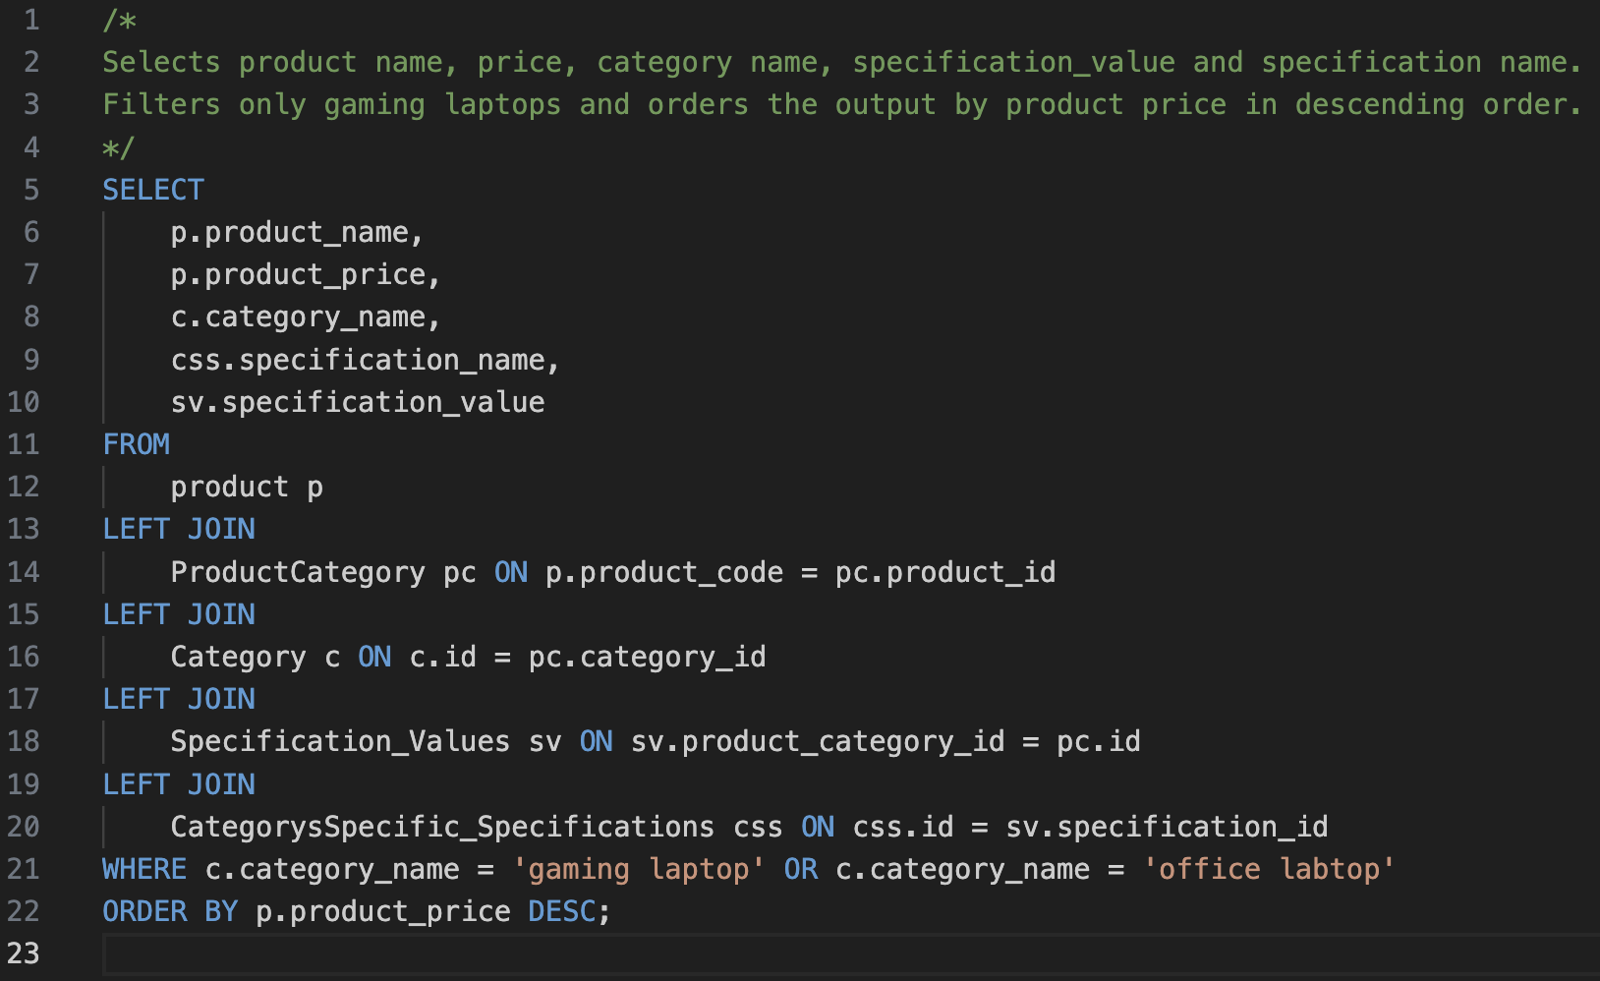

Figure 19 shows the Query 1

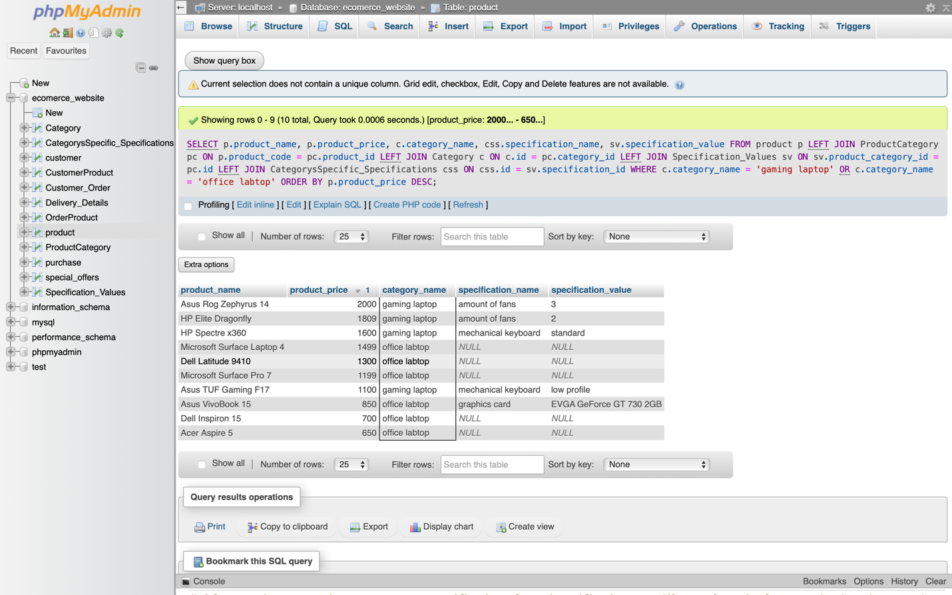

Figure 20 show the output table of Query 1

### 5.1.4 Explanation of output table

The output table contains data from 5 tables that are now connected to each other, using joins. The table has product name, product price, category name, specification name and specification value as expected, in descending order, containing data that related only to products which categories are gaming laptop or office laptop.

## **5.2 Query 2**

### 5.2.1 Business purpose

As a Database Administrator, my goal is to create a sorted procedure for updating Order totals. This will ensure data integrity by preventing Web Developers from directly modifying records, thereby safeguarding against erroneous or unauthorized changes.

### 5.2.2 Query in natural language

The query lists each customer’s order in a detailed manner, starting with a unique index number for each row. It organizes this information primarily by the customer’s first name, the date of the order, and the price of the product in descending order. For each order, it shows the customer’s title and first name, the payment method and reference used, the order number, order date, total price of the order, and invoice number and date. The delivery details are included, showing how the product was received, whether the delivery was fast or standard, the cost of delivery, and the shipping information. Product details are also provided, including the product code, the quantity of each product ordered, the name of the product, and its individual price.If there was a special offer applied to any of the products, this information is included. Lastly, the query calculates the savings for each order by subtracting the total cost of the products from the total order price.

### 5.2.3 SQL code and output

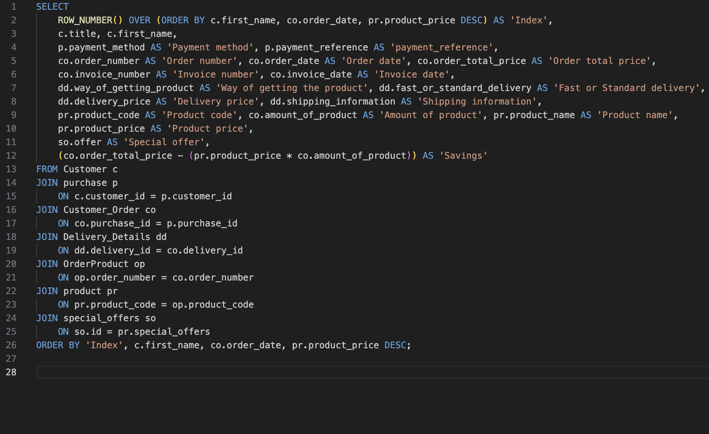

Figure 21 shows the Query 2

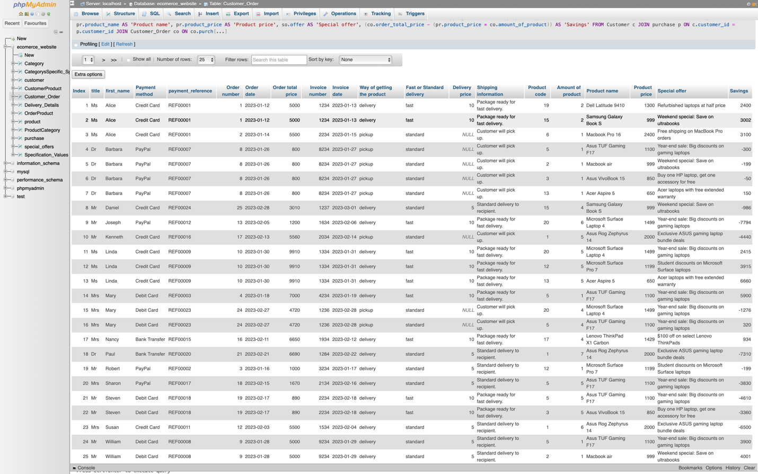

Figure 22 shows the output table of Query 2

### 5.2.4 Explanation of output table

The output table contains multiple columns of combined tables. The output was manually compared with the values in the database tables, and all values were as expected.

Some of the values in the last column “Savings” can be negative, because when the data for tables was generated, columns such: order_total_price, amount_of_product, product_price were not compared. Therefore, some values might not match.

## **5.3 Query 3**

### 5.3.1 Business purpose

As a Data Analyst, I want to know the most sold computer and its category for the January 2023 1st to February 2023 1st.

### 5.3.2 Query in natural language

Select the order date, product name, and category name from a series of joined table that include purchases, customer orders, order products, products, product categories, and categories. Calculate the cumulative sum of the amount of product for each category, making sure this sum is reset for each category and ordered by the order date within each category. This cumulative sum is calculated for orders placed between January 1st , 2023, and February 1st, 2023. Finally, order the resulting data first by this cumulative sum in descending order, and then by the order date.

### 5.3.3 SQL code and output

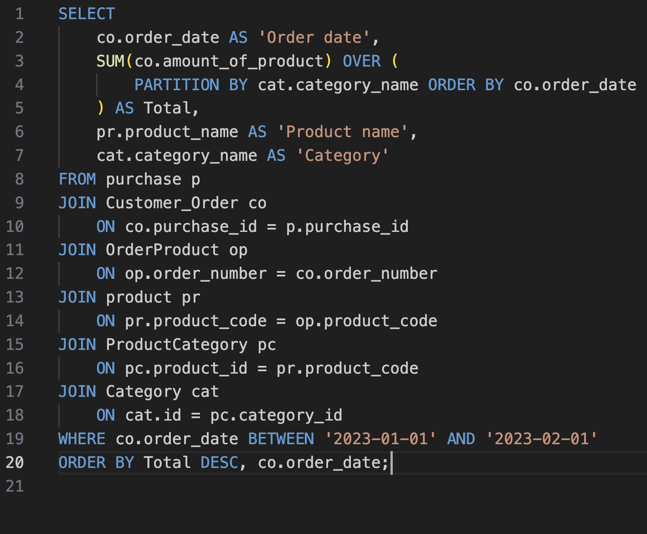

Figure 23 shows the Query 3

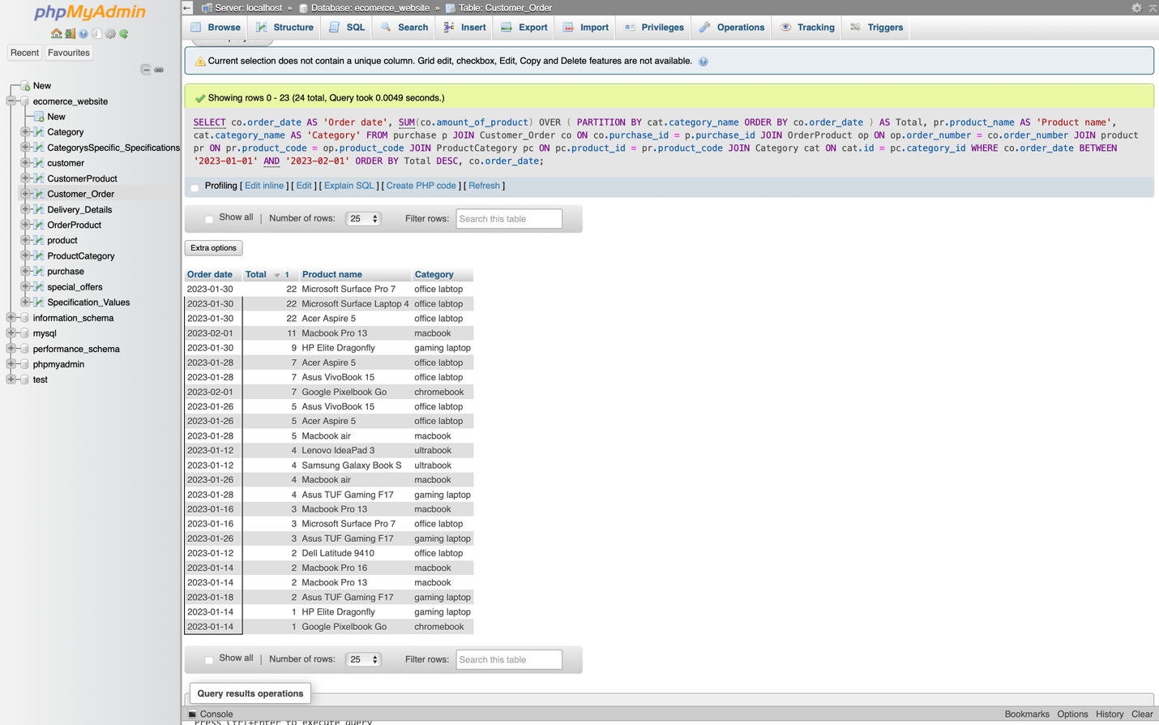

Figure 24 shows the output table of Query 3

### 5.3.4 Explanation of output table

The output contains expected table that has six joined. All values correspond to the related values as expected. The query has produced an output that includes a detailed listing of product orders, focusing on the date of order, the product name, and the category to which each product belongs. The query retrieves data from multiple tables that are interconnected: purchases, customer orders, order products, products, product categories, and categories.

## **5.4 Query 4**

Here I have provided two versions of the same query. Both queries output the same result, they only have different approaches.

### 5.4.1 Business purpose

As a Data Analyst, I want to identify products within the ‘macbook’ category that have an average rating lower than the average rating of all products in the same category. This information is crucial for understanding which products are underperforming in terms of customer satisfaction, guiding quality improvement initiatives, adjusting marketing strategies, managing inventory, and potentially revising pricing strategies. The goal is to enhance overall product performance and customer satisfaction within this specific category.

### 5.4.2 Query in natural language

Find the names and average ratings of all products that belong to the ‘macbook’ category. However, only include those products whose average ratings are lower than the average rating of all products in the ‘macbook’ category.

### 5.4.3 SQL code and output

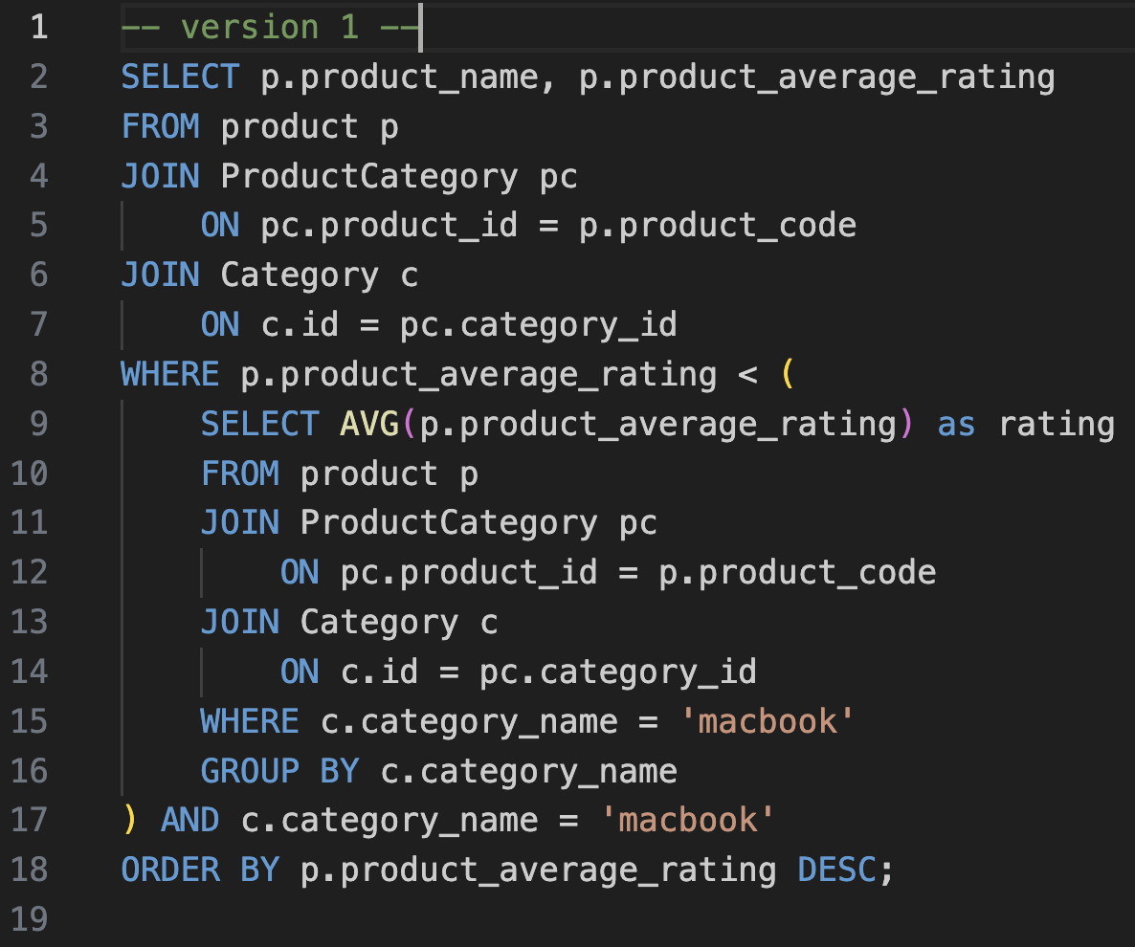

Figure 25 shows the Query 4, version 1

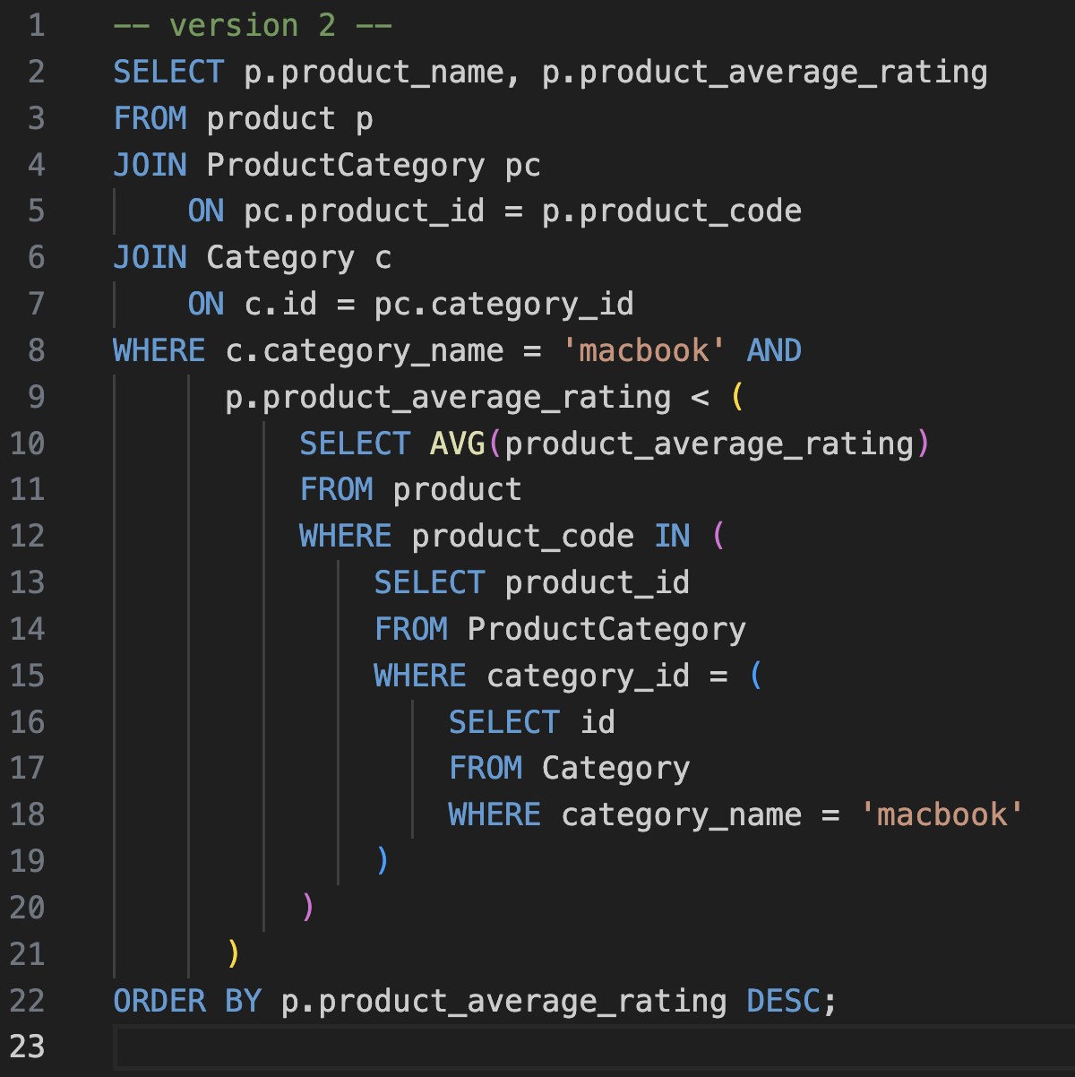

Figure 26 shows the Query 4, version 2

Output table for Version 1 query

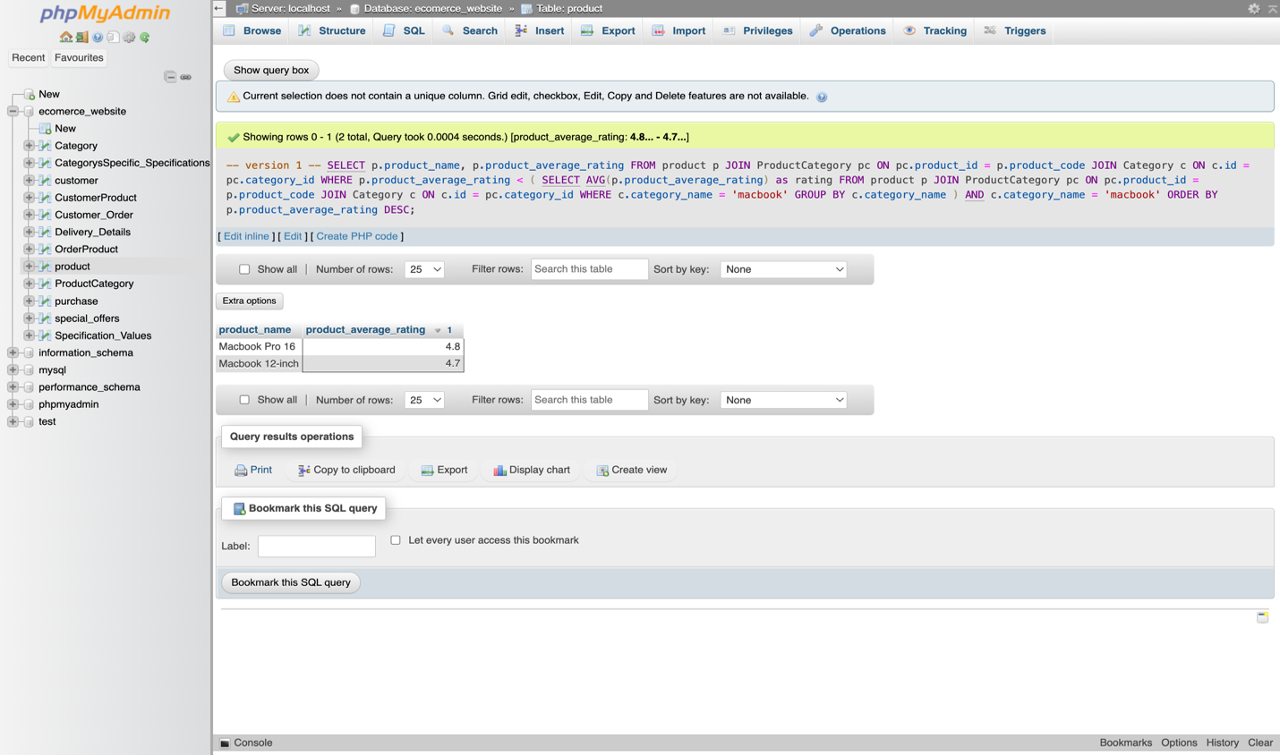

Figure 27 shows the output table for Query 4, version 1

Output table for Version 2 query

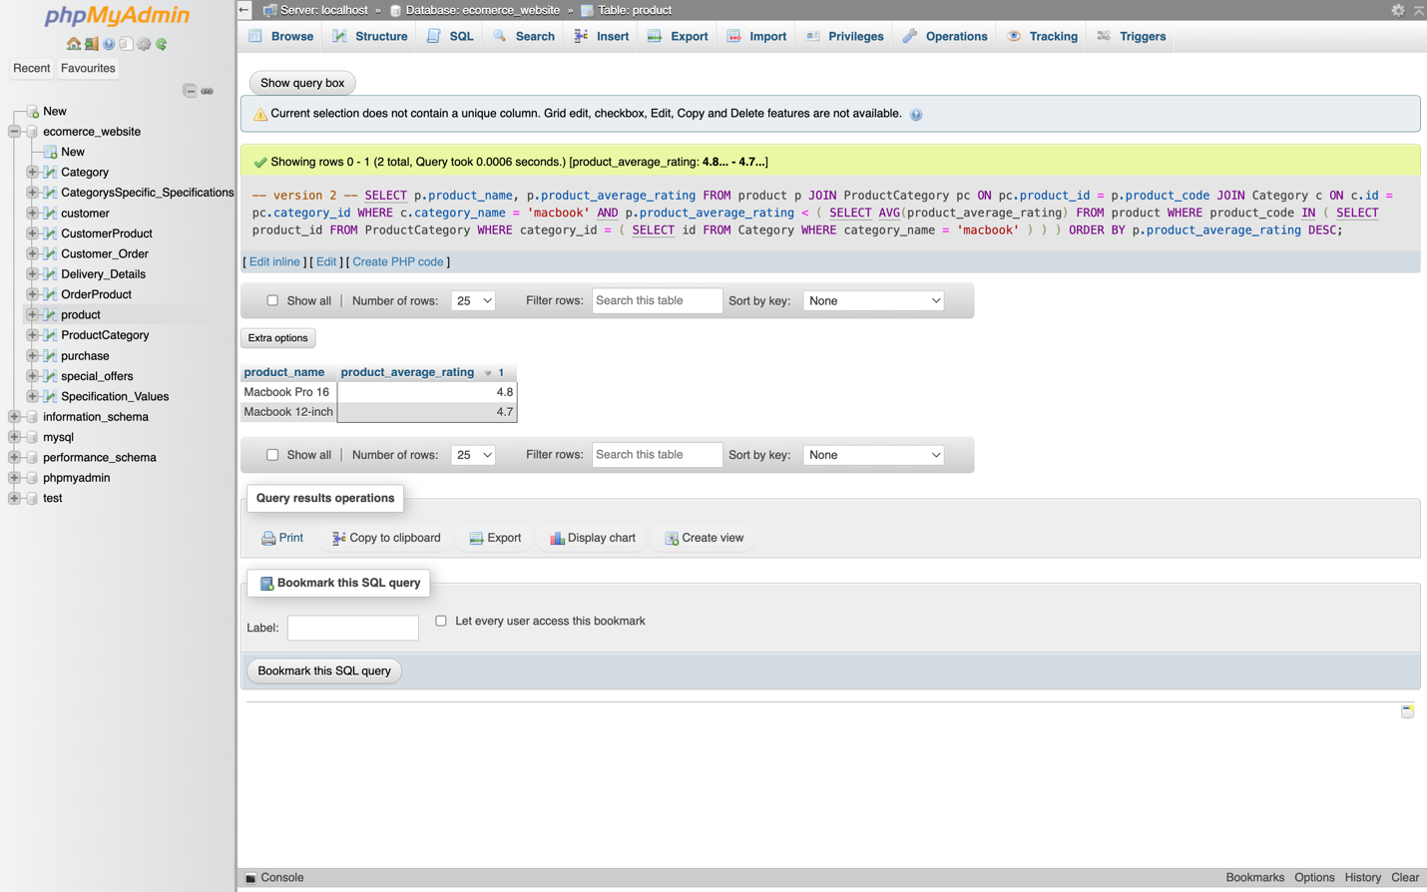

Figure 28 shows the output table for Query 4, version 2

### 5.4.4 Explanation of output tables

Each output table contains expected result and values.

First version uses mostly joins, it first creates subquery that selects average rating for ‘macbook’ category, then selects macbooks that have less rating than the average macbook, and orders all in descending order by rating.

Second version uses more direct approach to find the average rating of products in the ‘macbook’ category. It first finds the category ID for ‘macbook’, then finds the product IDs in that category, and finally calculates the average rating for these products.

## **5.5 Query 5**

### 5.5.1 Business purpose

As a Data Analyst, I want to analyze each customer and split them into the categories with their statistic data.

### 5.5.2 Query in natural language

Identify each customer in categories and see their statistics, such as: average order price and total time online, display records from 1st January to 1st February.

### 5.5.3 SQL code and output

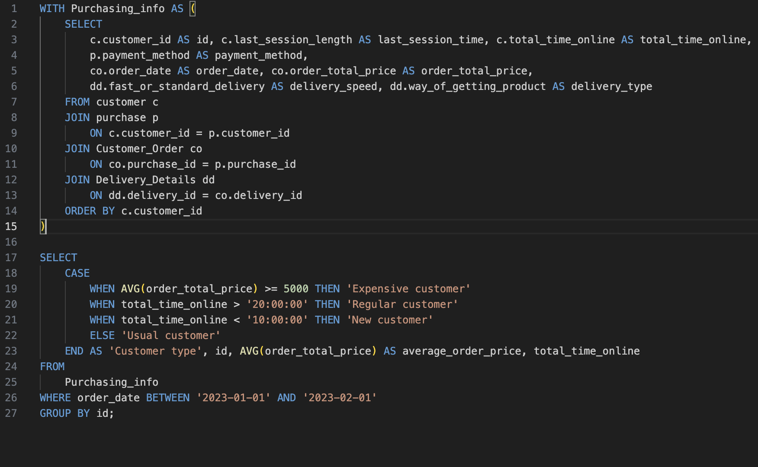

Figure 29 shows the Query 5

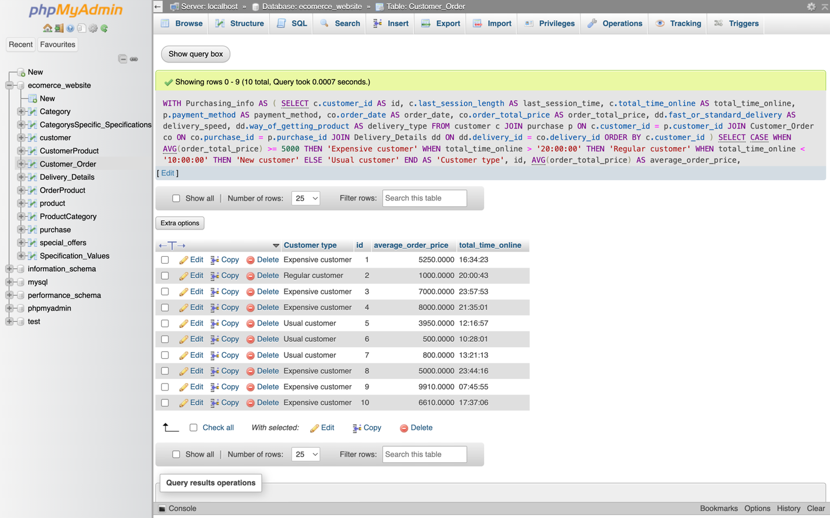

Figure 30 shows the output table for Query 5

### 5.5.4 Explanation of output table

The provided output table contains expected result and values. The query is made of a temporary table that can be used separately, which contains order information of each customer, and main query that uses CASE statement to split each customer according to their order data. All data was taken from 1st January to 1st February.

# **6 References**

1. Argos. (1972). Order online today for fast home delivery. Available at: <https://www.argos.co.uk> [Accessed 20 September 2023].
2. John Lewis & Partners. (1864). Department Store | Home, Fashion, Tech & More. Available at: <https://www.johnlewis.com> [Accessed 21 September 2023].
3. Currys. (1884). Currys. Available at: <https://www.currys.co.uk> [Accessed 22 September 2023].
4. Decomplexify. (2022). Learn Database Normalization – 1NF, 2NF, 3NF, 4NF, 5NF [Video]. YouTube. Available at: <https://www.youtube.com/watch?v=GFQaEYEc8_8> [Accessed 15 October]